# Interim Summary, 05Jan 26, 08Sep 25, 08Jul25

New material 05Jan26: transformation between KC with inhibition turned off (TNTlabel) and three kinds of controls (TNT3c)

## Coordinate sets: ORN, KC, and model

**ORN datasets** consist of megamat17-wd (with diagnostics), 17 test odorants, 9 preps, and validation2-wd, 22 test odorants, 6 preps. Odor sets are not overlapping.

To create the merged datasets:

* For each of megamat17-wd and validation2-wd, the array of (roi x odorant) responses was combined across preps by a(fly)+b(fly)x(roi,odorant), yielding a set of regression values x for each (roi,odorant) pair using a linear regressoin/missing data algorithm (afalwt.m, JV). The b’s are fixed to have an RMS of 1, so that the regression coefficients properly reflect the sizes of the responses. 17 odorants in megamat17-wd, 22 in validation2-wd

* These datasets are then concatenated to yield a larger (roi,odorant) array. In the “inter” datasets, only the orn’s present in both are used. In the “union” datasets, all of the orn’s are used, and if an orn is missing in one dataset, values are set to zero.

* Then, principal components of the x(roi,odorant) array are computed, without subtracting the mean across odorants. This yields orn_merged/hlid_odor039_coords_merged_[inter|union].mat. There is almost no difference between inter and union, and the union process is used from here on.

To restrict attention to the 16 odorants also present in the kc-tnt experiments, principal components were recomputed by resynthesizing the responses from all principal components, and then computing the PCs just from the 16 stimuli in common. This yields **orn_merged/hlid_odor039_coords_merged_union-ovlp16.mat**, which contains the responses to all 39 odors projected into the PC space of the common 16. (

Alternatively, the, principal components of x(roi,odorant) were computed only for the 16 common odors, directly from the regression coefficients, and alphabetized (to enable some visualization software to work). This yields **orn_merged/hlid_odor039_coords_merged_[inter|union]-ovlp16sel-alpha.mat**, which has coordinates only for the 16 stimuli. Note that the “ovlp16” and the “ovlp16sel-alpha” datasets have some pc’s flipped, but they are otherwise identical for the 16 common stimuli. That dataset is used for all of the definitive modeling for the transformatoin from ORN space to KC space.

These coordinate sets are not zero-centered (since the PC’s are of the actual responses, without mean-subtraction.

These coordinate sets are “nested”: the first M dimensions of an N-dimensional space (M<N) is the same as the M-dimensional space.

**KC datasets**

*Non-nested datasets*

Since there is no “roi” to compare across preps, a different strategy was used: for each prep do pca on the (kc,odorant) matrix, retain the first M pc’s, and then do a consensus alignment across preps. The consensus alignment allows for origin shifts and rotations, to minimize the total, across odorants, of the RMS distances between the centroid of the responses, and each of the individual prep’s responses. Done with procrustes_consensus.m (JV) and psg_align_knit_demo.m (JV). Optionally, this alignment can allow for an overall scale for each prep. When this is done, the final alignment is scaled so that their geometric mean is 1.

hlid_odor17_coords_TNT3c_consensus_[no]scale: consensus across all 3 kinds of controls (11 preps)

hlid_odor17_coords_TNTin-nolabel_consensus_[no]scale: consensus across inactive, no label (3 preps)

hlid_odor17_coords_TNT-nolabel_consensus_[no]scale: consensus across active, no label (2 preps)

hlid_odor17_coords_TNTin-label_consensus_[no]scale: consensus across inactive, label (6 preps)

hlid_odor17_coords_TNT-label_consensus_[no]scale: consensus across active, label (8 preps) – experimental condition

These are zero-centered, as a consequence of the consensus.

They are NOT nested: the N-dimensional model is a consensus of the first N pc’s, and adding pc’s may change the consensus – for example, if a lower pc in one prep corresponds to a higher pc in another. (adding pc’s may also worsen the consensus, e.g., b/o noise). Only the noscale versions are used from here on.

For comparison with the ORN data, at the 16 common stimuli (omitting pfo), non-nested datasets are

hlid_odor17_coords_TNT[3c|-label]_consensus-pc_noscale-ovlp16NoNest[-alpha].mat

created by psg_coord_pipe_proc.m (JV). The only difference is that the -alpha sets have the stimuli alphabetized and omit pfo (both are alphabetized, this is a side effect of the consensus calculation)

*Nested datasets*

There is a parallel analysis with a nested version, in which the consensus is calculated across preps based on all 17 PC’s, and then the first N pc’s are used for the N-dimensional model. This is calculated via psg_coord_pipe_proc from the 17-pc consensus. Files are

hlid_odor17_coords_TNT[3c|-label]_consensus-pc_noscale-ovlp16[sel-alpha].mat

The sel-alpha datasets have only the 16 common stimuli, and both are alphabetized.

**Model coordinate sets**

These are determined after fitting an affine model from the ORN space (16 stimuli in common, union, nested)

**orn_merged/hlid_odor039_coords_merged_[inter|union]-ovlp16sel-alpha.mat**

to a KC dataset, non-nested

**hlid_odor17_coords_TNT[3c|-label]_consensus-pc_noscale-ovlp16NoNest[-alpha].mat**

or nested

**hlid_odor17_coords_TNT[3c|-label]_consensus-pc_noscale-ovlp16[sel-alpha].mat**

yielding models of what the KC space would be if the affine model is exact:

non-nested:

**hlid_odor039_coords_merged_union-ovlp16NoNest-alpha_mdl[3c|-Label].mat**

or nested:

**hlid_odor039_coords_merged_union-ovlp16sel-alpha_mdl[3c|-Label].mat**

## Main observations: the geometry of the spaces, ORN to KC transformation

* There is sufficient consistency of the KC rsponses, in both control and inhibition-off conditions, to require a representational space use of at least 5 dimensions. This is based on the incremental RMS variance explained by adding additional dimensions (compared to a shuffle of the residuals from one dimension less, red)

Control: plots\kc-TNT3c_align_stats_13Nov24.fig (all 11 preps combined), top

Inhib-off: \plots\kc_TNT-label_align_stats_29Oct24.fig (6 preps), bottom

quantiles from 100 shuffles: 0.0100 0.0500 0.5000 0.9500 0.9900

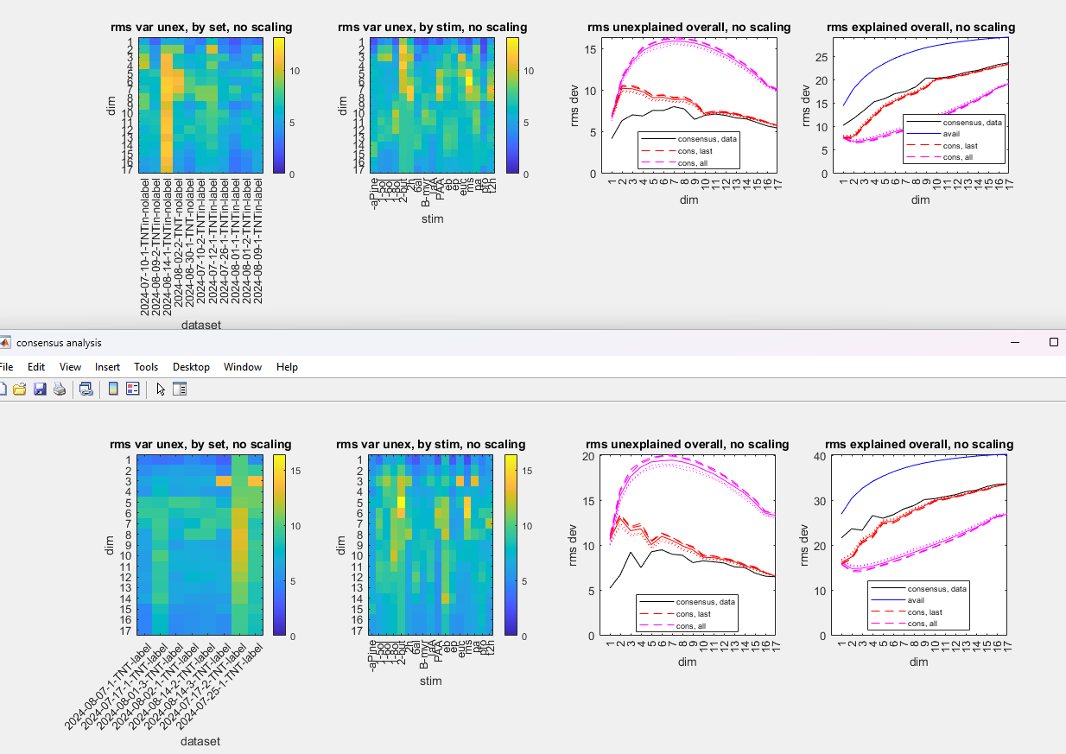

* The KC spaces for the control and inhibition-off are different – at least up to dimension 5. This is model-independent, and based only on comparing the variance explained for a consensus among the control and inhibition-off preps, vs relabelings. See plots/psg_align_vara_TNTlabel-TNT3c_29Nov24.fig

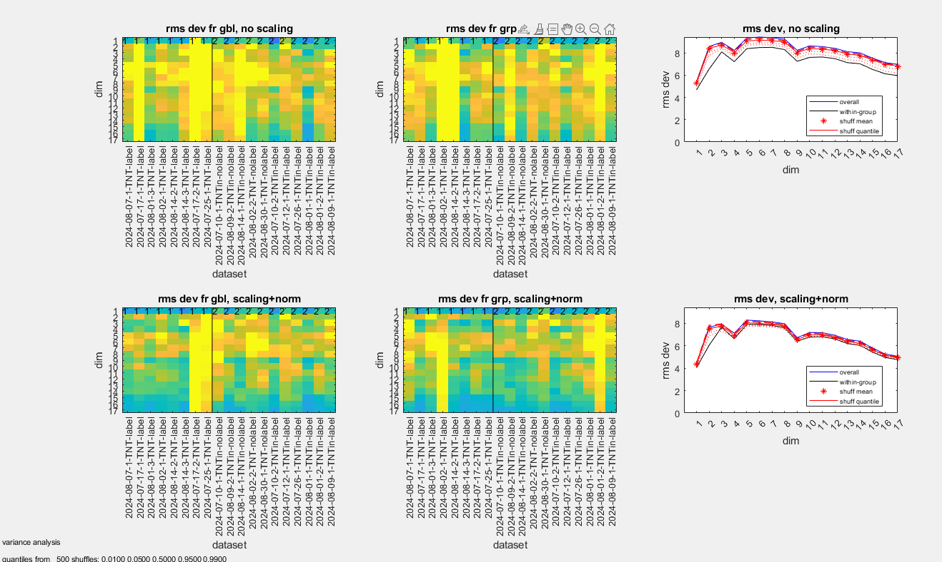

* The affine model (i.e., linear but with anisotropy allowed) is a better model than a model that is linear and isotropic, for both control and inhibition-off. This is manifest by a greater variance explained by a shuffle test, at 3, 4, and sometimes 5d. Here, showing just the no-nest analysis, control on left, inhibition-off on right, from

psg_geomodels_run_orn039union_TNT[3c|Label]Noscale-pc-ovlp16NoNest_7d_procrustes_vs_affine.fig

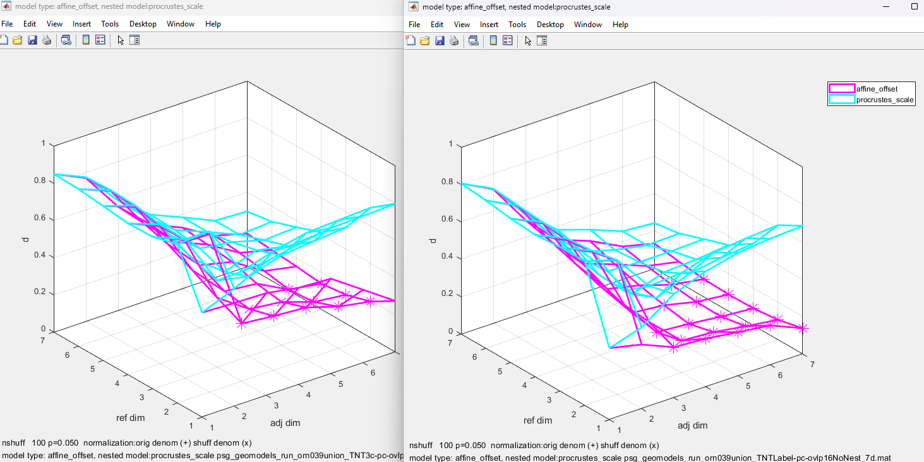

* The anisotropy in the affine model is greater than that of the random connectivity or hemibrain model (grant)

* The anisotropy in the affine model is particularly large when one compares the least-compressed to the most-compressed dimension, and is larger in the control than when inhibition is off. HOWEVER, for the most-compressed dimension, the affine model is least reliable – as an index of reliability, the projections onto the principal axes should be the same in the ORN and KC space. Reproducing here the notes from a recent email:

Say the affine transformation is w=Av, v in the ORN space, w in the KC space, A any square matrix.

The length of the vector in the range space is wTw = (Av)T(Av)=vT ATAv.  This is a quadratic form in v, so, to find the extrema of the length of Av for all unit vectors v, we need to find the eigenvectors of ATA.  The projections of the odors onto these vectors are plotted as the rows in the lower left heatmap.

For the lower right heatmap, we look at v=A-1w, using the above analysis.  So we want to find the eigenvectors of (A-1)TA-1.    This matrix is the inverse of AATas can be seen by multiplying

(A-1)TA-1 AAT=(A-1)TAT=(AA-1)T=I.

The key point is that if v is an eigenvector of ATA with eigenvalue b, then Av is an eigenvector of AAT also with eigenvalue b: AAT(Av)= A(ATA)v=Abv=b(Av).  So Av is an eigenvector of (AAT)-1

with eigenvector 1/b.  This is a long way of saying that the transformation maps principal axes in the domain space into principal axes in the range space.

So, if the odor points moved in a way that fully conformed to the transformation, their projections onto the principal axes in the domain space (lower left heatmap) would match their pro9jectdions on to the principal axes in the range space (lower right heatmap).  To the extent that they don’t, it means that the transformation of the axes does not explain the way that the odor points move – and therefore it makes sense that the compression in the last dimension of the transformation does not correspond to what the data does.

This holds both for the Nest analysis , at dimensions 3, 4, and 5, and for the NoNest at dimensions 4 and 5.

Nest: hlid_majaxes_24Jun25.pdf, pages 5 (control), and 15 (inhibition off) (left, top and bottom)

NoNest: hlid_majaxex_05Jul25.pdf, pages 5 (control) and 15 (inhibition off) right, top and bottom)

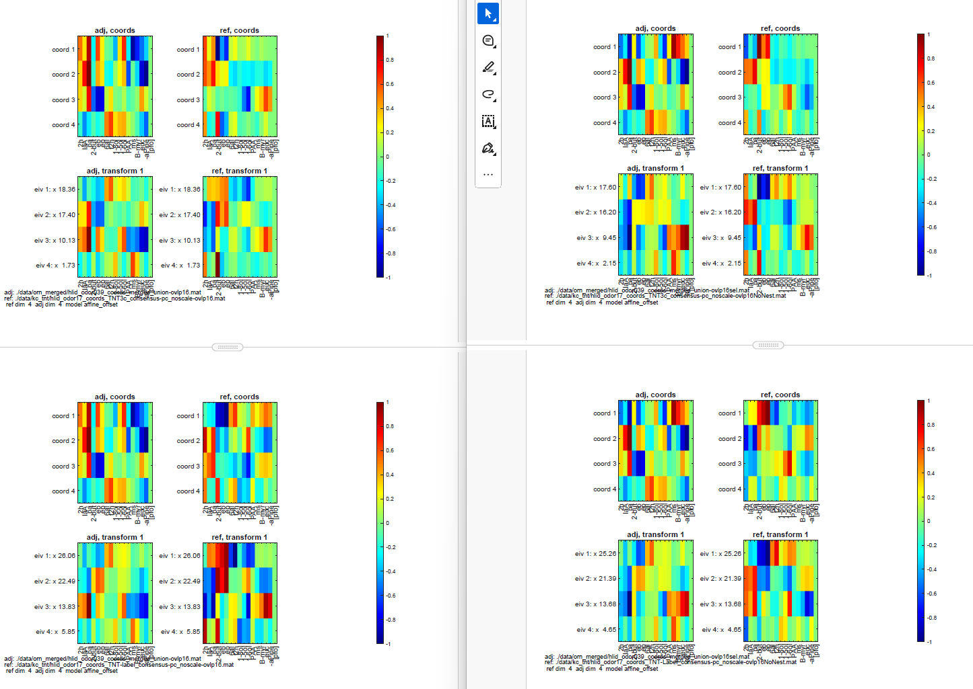

* Another piece of evidence that although the affine model fits better than a uniform model, it is incomplete – from hlid_orn_kc_mdlsum_09Jul25.txt. This simply shows “d”, the standard measure of a Procrustes fit, between the merged dataset without (second column) and with (third column) the anisotropic component. D=0 for a perfect fit, 1 for no fit at all. Note that although the fit is always better when a transform is included, it is not all that much better – only explains about 1/3 of the remaining variance. But also note that the correct merged model is a better fit than the merged model for the other condition (i.e., fitting the control KC with the orn->inhibition off KC transform model)

Nested datasets:

procrustes evaluation of fits

orn to control kc

dim merged merged+xform merged+xform of other condition

1.0000 0.9630 0.9630 0.9630

2.0000 0.7667 0.7441 0.7487

3.0000 0.4899 0.4304 0.4436

4.0000 0.4249 0.3287 0.3405

5.0000 0.4121 0.3262 0.3436

6.0000 0.3082 0.2275 0.2482

7.0000 0.3318 0.2231 0.2349

orn to TNT-label kc

dim merged merged+xform merged+xform of other condition

1.0000 0.7374 0.7374 0.7374

2.0000 0.5926 0.5649 0.5727

3.0000 0.4007 0.3474 0.3626

4.0000 0.3224 0.2344 0.2478

5.0000 0.3284 0.2482 0.2676

6.0000 0.2748 0.1920 0.2136

7.0000 0.2543 0.1557 0.1686

Non-nested datasets:

orn to control kc

dim merged merged+xform merged+xform of other condition

1.0000 0.5621 0.5621 0.5621

2.0000 0.8654 0.8494 0.8613

3.0000 0.4653 0.3733 0.4117

4.0000 0.3775 0.2722 0.2823

5.0000 0.4022 0.2961 0.3149

6.0000 0.3070 0.2097 0.2387

7.0000 0.2975 0.1783 0.1952

orn to TNT-label kc

dim merged merged+xform merged+xform of other condition

1.0000 0.3830 0.3830 0.3830

2.0000 0.7195 0.7171 0.7394

3.0000 0.4183 0.3442 0.3844

4.0000 0.2670 0.1666 0.1782

5.0000 0.3037 0.1791 0.2011

6.0000 0.2584 0.1475 0.1788

7.0000 0.2423 0.1327 0.1506

* The difference between the Nest and NoNest reconstructions are smaller than the difference between control and inhibition-off. One can see it on vis_TNT3cLabel_NestNoNest_16stims_4d3.fig (4-d model, in each subset of 3 dimensons): blue is control, red is inhib-off, dark dots are NoNest, paler dots are nest

From vis_TNT3cLabel_NestNoNest_16stims_4d3.fig:

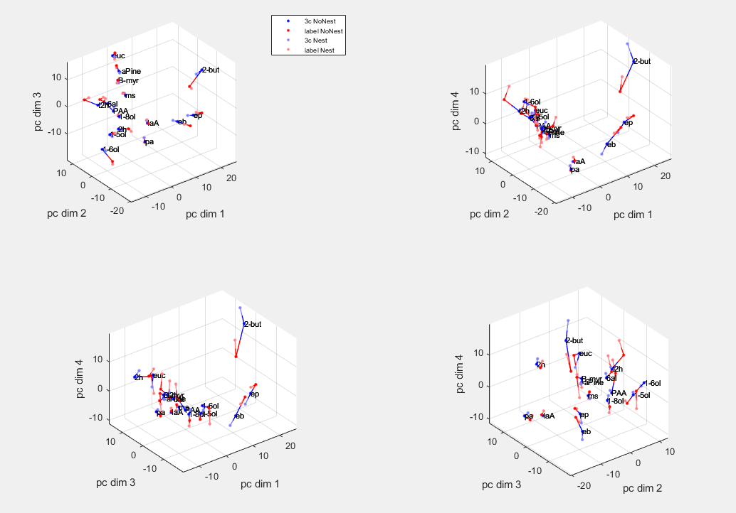

This is also quantified by hlid_kc_mdlcomp_10Jul25: at dims 4 and above (and partially at dimension 3), the difference between control and inhib-off is greater than the difference between nested and non-nested constructions.

3c vs label Nest vs NoNest

dim Nest NoNest 3c label

1.0000 0.6288 0.1747 0.9988 0.5047

2.0000 0.2434 0.4343 0.3740 0.0960

3.0000 0.0607 0.1044 0.1029 0.0478

4.0000 0.1079 0.0700 0.0271 0.0496

5.0000 0.0537 0.0816 0.0296 0.0420

6.0000 0.0630 0.0703 0.0328 0.0292

7.0000 0.0499 0.0433 0.0240 0.0270

* Although the affine model is far from perfect, it captures at least some of the difference between control and inhibition-off. Again I haven’t quantified htis, but once can see it on vis_ORN_TNT3cLabel_Nest_model_16stims_[3d|4d3].fig and the parallel NoNest files. Green is the best fit of the ORN space to the KC data using just an overall gain change. The pale red and pale blue dots are the best affine fits, and the sold red and solid blue are the actual KC data (blue: control, red: label). One can see that usually – but not always – the pale dots move from green towards the solid dots, i.e.,the affine model is a better fit than the uniform model – but they often don’t get very close. OTOH the green-to-pale-blue-to blue trajectory and the green-to-pale-red-to-red trajectories are somewhat separate, so the model indeed captures some of the differnce between control and inhib-off.

From vis_ORN_TNT3cLabel_NoNest_model_16stims_3d.fig:

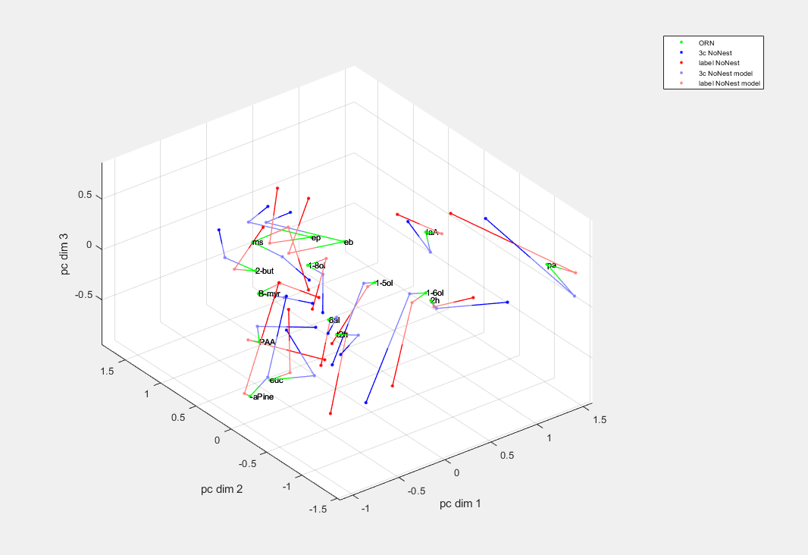

## Trial-to-trial variability

* When constructing a space from individual trials, we saw that the individual trials’ loci occupied a “fan”, rather than the full volume. This held for control and inhibition-off. While the fan tended to point towards the origin, it was not simply due to amplitude variation (since it was 2-d). This pattern was consistent across preps, as can be seen from these plots, in which data from individual preps were merged by a Procrustes transformation that aligned the mean responses. First, second, and third trials are red, magenta, and cyan. The star is the origin. This is \plots\hlid_rastim_trial_vis_15Jan25_TNT3c_consensus_raw_stim_d[123|234].fig, similar findings for Label, and with mean subtracted.

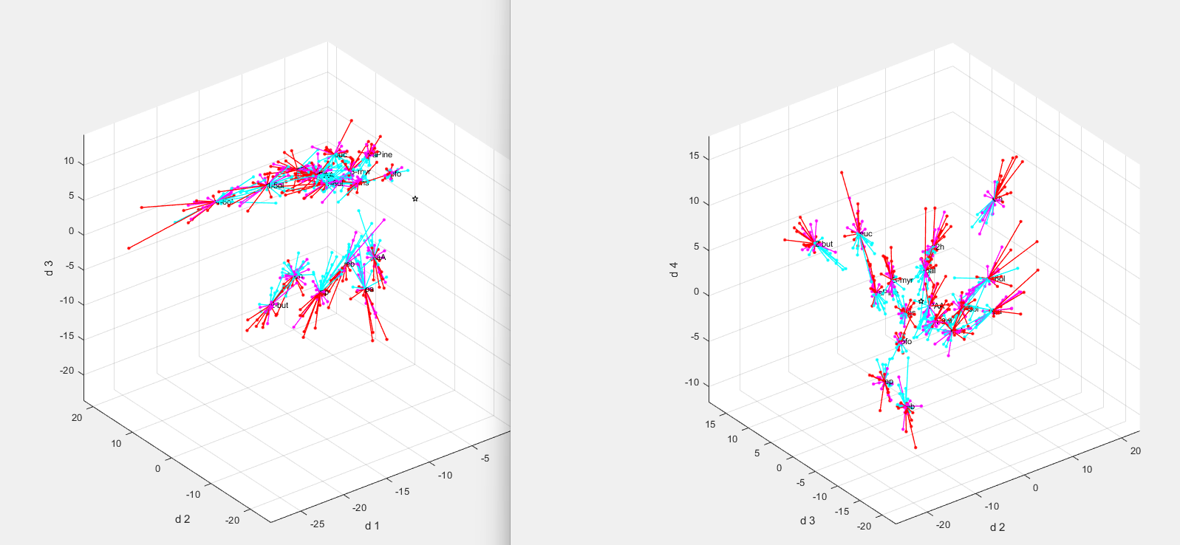

* Statistical analysis of this:

Analyses 28Dec24 to 08Jan25 with kc-soma-nls datasets with hlid_rastim_trial_[pca|pcs2|vis|vis2].m: Strategy is to look at residuals, fix 0, 1, or 2 eigenvalues of the covariance matrix, and then randomly rotate in the other directions, and see whether there is excess covariance in the next eigenvalue. This is carried out separately for each stimulus. For many of the stimuli, the amount of variance in the first un-fixed eigenvalue of the actual data is larger than for the surrogates. Below is from hlid_rastim_trial_vis2_08Jan25_kc-soma-nls_d6.pdf., each stimulus is a color; first line fixes no eigenvalues, second line fixes 1 eigenvalue, third line fixes two eigenvalues.

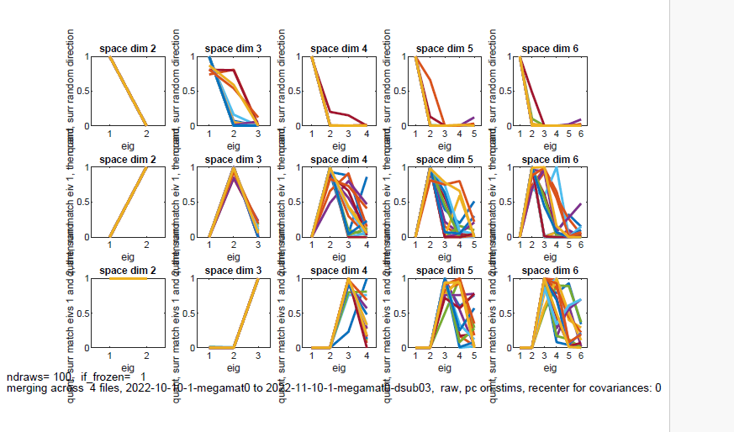

## Decoding in KC: control (tnt3c) and inhibition off (tntlabel)

* Initial analysis, up to 7-dimension embedding, decoding across flies

hlid_rastim_trial_decode_confmtx_06Feb25_TNT3c.txt, hlid_rastim_trial_decode_confmtx_07Feb25_TNTlabel.txt:

There were 8 TNT-label datasets and 11 total controls. To keep things fair, the controls were analyzed in three random subsets of 8 datasets, and results pooled. For each subsample of 8 datasets, 17 folds were created, in which 1/17 of the (8 datasets * 3 repeats * 17 stimuli) were held out, the held-out stimuli could come from any repeat and any dataset. Two such configurations were made, and averaged over. Exact fold configuration can be found in mat-files, e.g., hlid_rastim_trial_decode_confmtx_07Feb25_TNTlabel.mat, in results.xv_configs. Dashed lines are an example of what’s held out

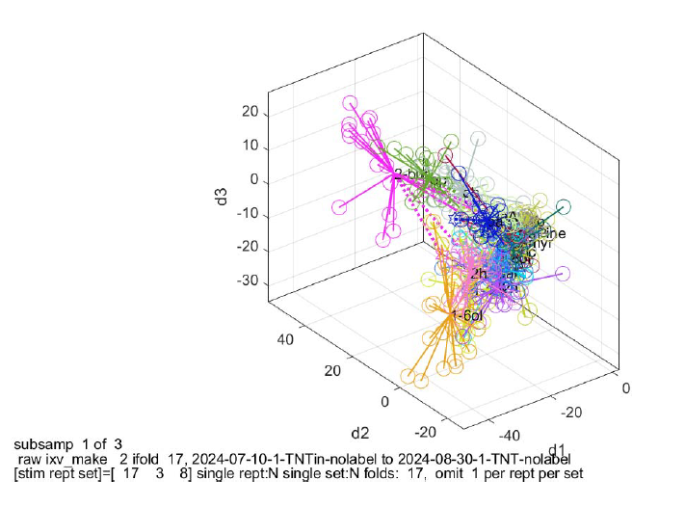

Decoding was based on any of several distance: Euclidean, 1-cosine, and Mahalanobis, with decoded stimulus assigned either to the minimum mean distance, or the minimum distance to the centroid.

Procedure was carried out with raw responses, mean-subtracted responses, and normalized variants of both.

Findings: \plots\hlid_rastim_trial_decode_confmtx_[06Feb25_TNT3c|07Feb25_TNTlabel]_summ.fig, showed **somewhat better decoding when APL inhibition was turned off (label)** – bottom set of plots.

Here and below, files with “details” in the name are confusion matrices.

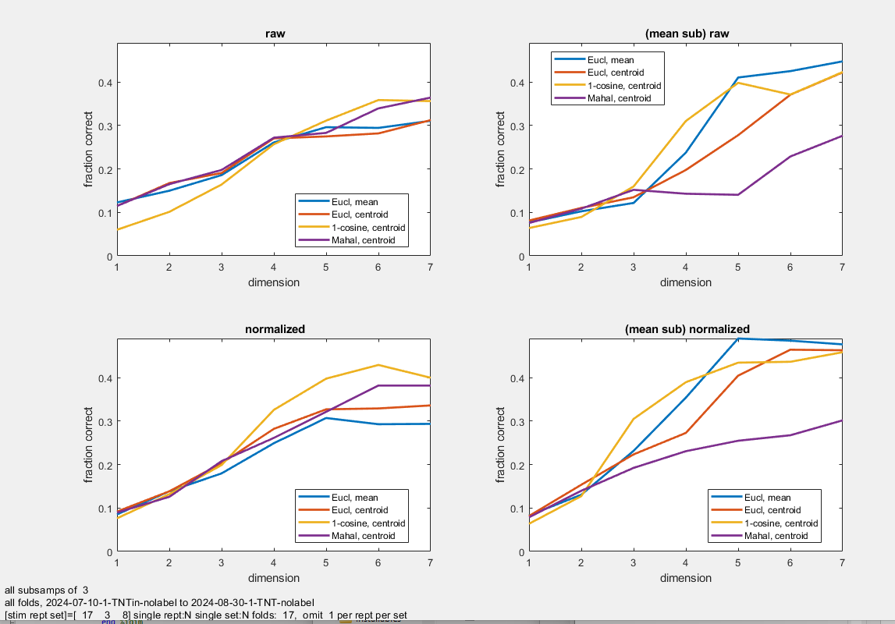.

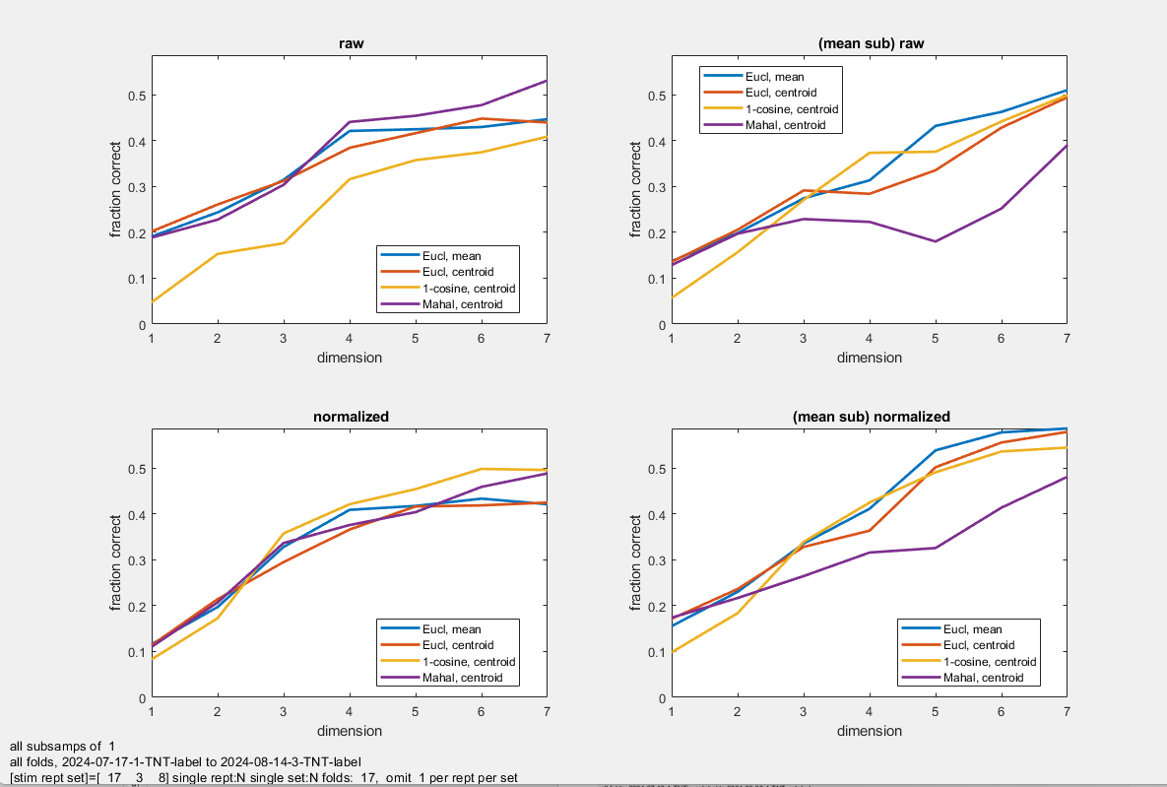

* Then we wondered if this was due to variability across flies, and perhaps, that APL inhibition was ore variable across flies, so turning it off improves decoding. This was explored by decoding within flies only.

\plots\hlid_rastim_trial_decode_confmtx_15Feb25_[TNT3c|TNTlabel].txt,

\plots\hlid_rastim_trial_decode_confmtx_15Feb25_[TNT3c|TNTlabel]_summ[_indiv].fig

**Findings persisted. “indiv” screenshots below, Indiv flies dashed) Label (inihb off) on bottom.**

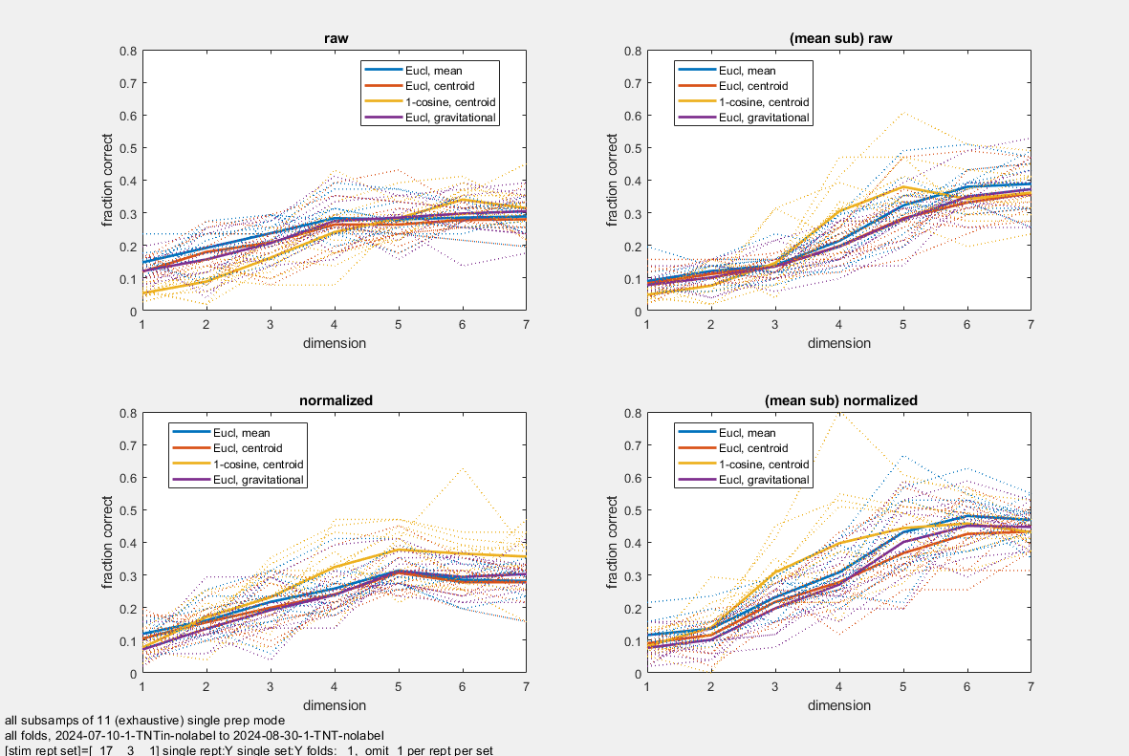.

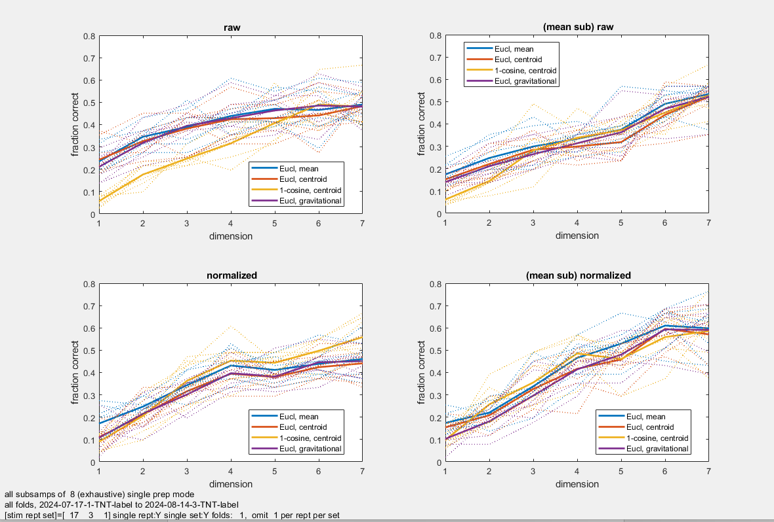

Then we wondered if the benefit of turning off inhibition was “denoising”. Analysis within flies, to higher dimension:

\plots\hlid_rastim_trial_decode_confmtx_17Feb25.txt,

\plots\hlid_rastim_trial_decode_confmtx_17Feb25_[TNT3c|TNTlabel]_d1_d16.fig

**Advantage of removing inhibition goes away at high dimensions. Label on the right.**

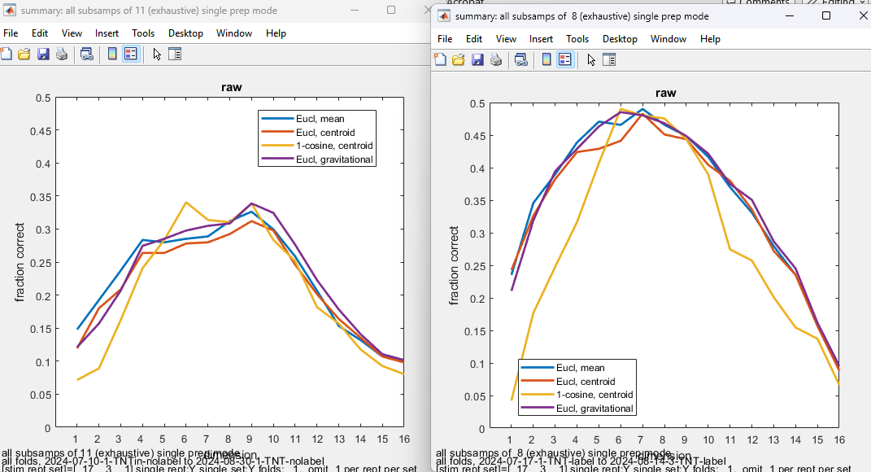

But with **no embedding whatsoever (implemented as 51 dimensions, decoding goes up substantially, and is slightly better in control (inhibition on, top), than with removal of inhibition (bottom).** Note that a “no embedding” calculation can only be done within single preps, since KC’s have no correspondence between preps.

hlid_rastim_trial_decode_confmtx_05Mar25_[TNT3c|TNTlabel].txt

plots\hlid_rastim_trial_decode_confmtx_05Mar25_[TNT3c|TNTlabel]_summ.fig

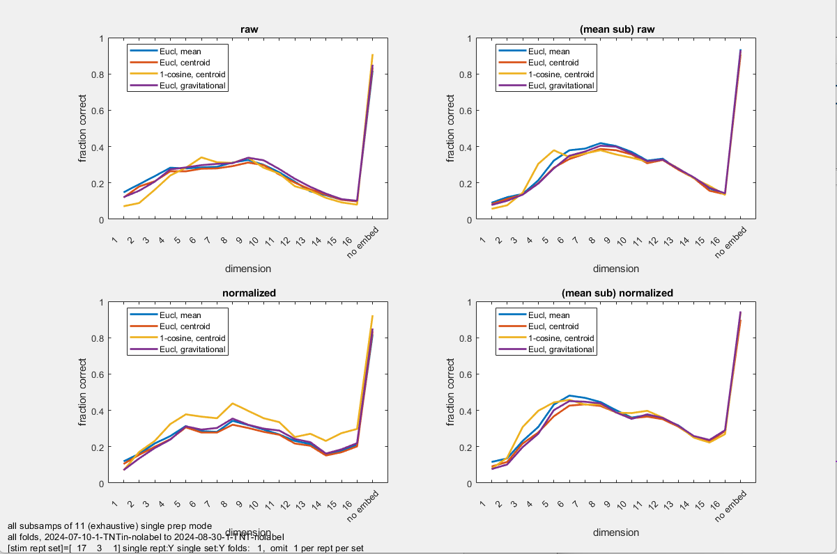

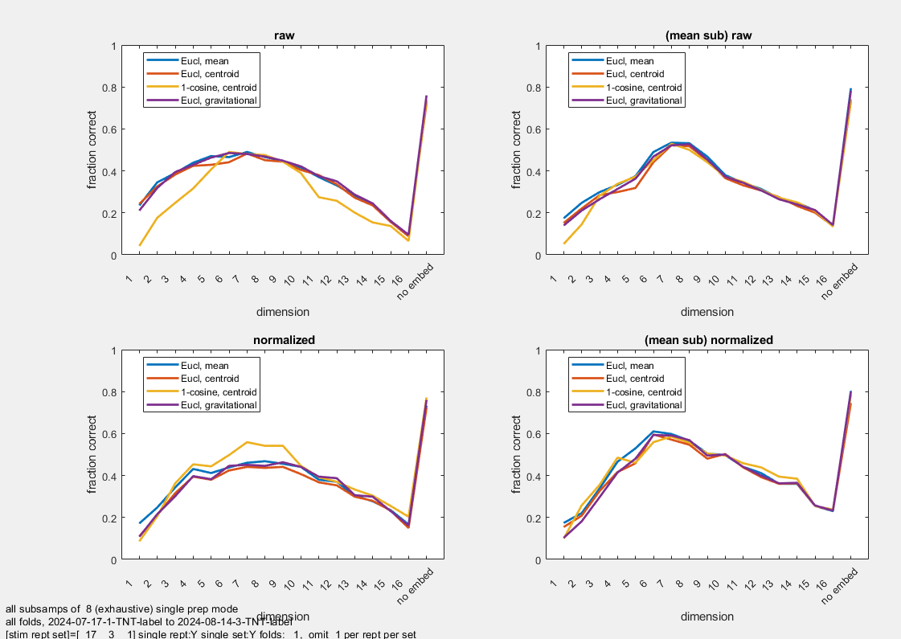

The non-monotonic behavior of fraction correct seems to reflect errors that are systematic: looking at information shows much less (or no) non-monotonicity **(inhibition on, top), removal of inhibition (bottom)**

hlid_rastim_trial_decode_confmtx_05Mar25_[TNT3c|TNTlabel].txt

plots\hlid_rastim_trial_decode_confmtx_05Mar25_[TNT3c|TNTlabel]_summ_info.fig

This led us to the discussion that there are multiple types of tasks – binary discrimination, identification of one in many, identification of same vs different

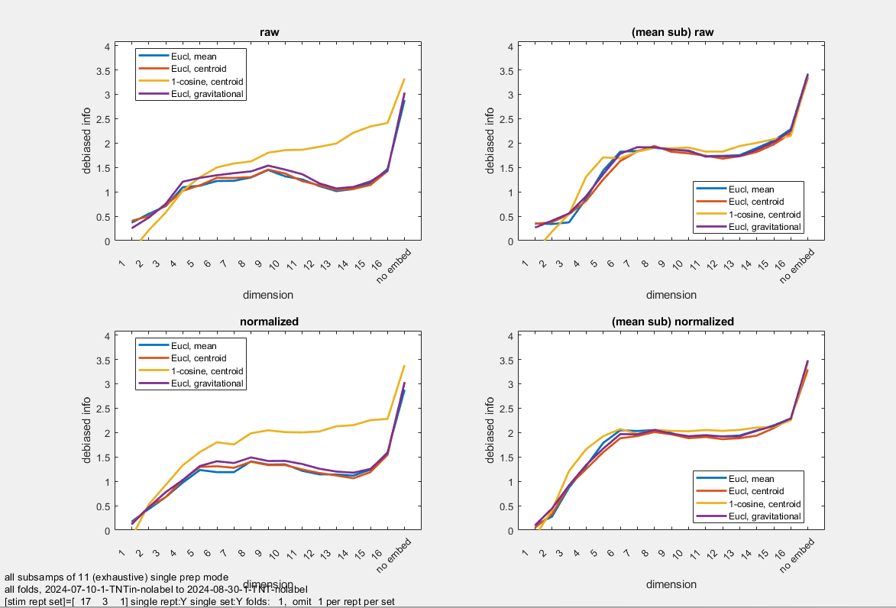

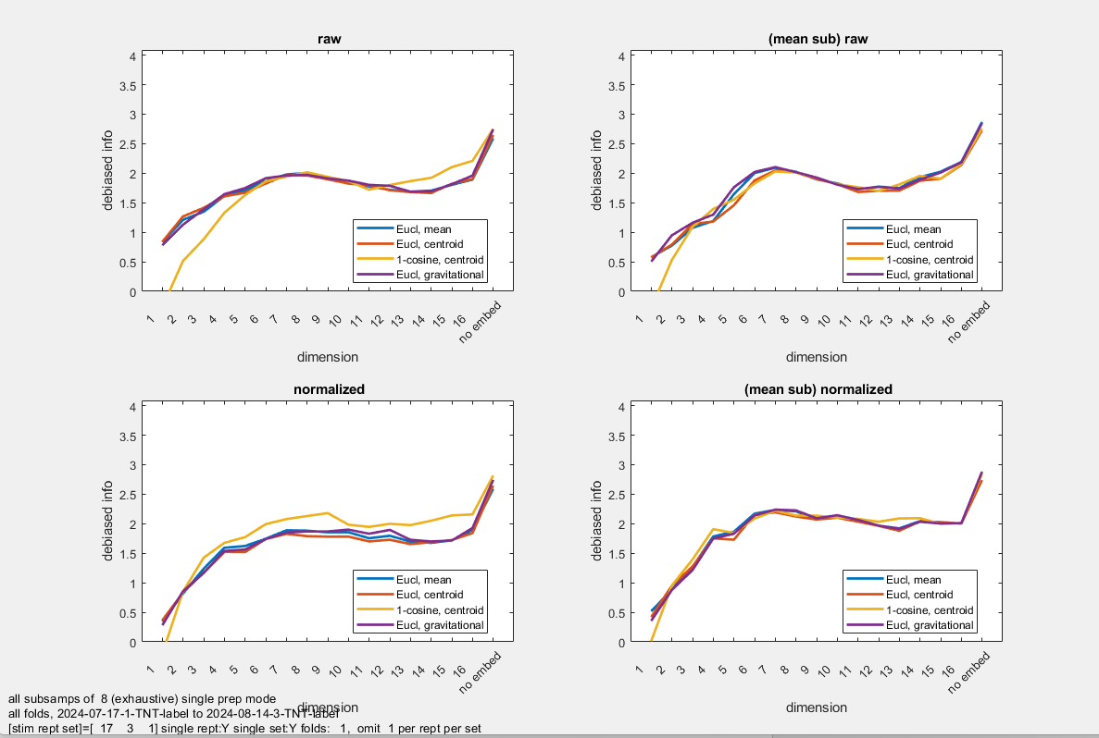

In an effort to look whether the repeat number was source of systematic variation, and also to explore the range between 16 and 51 dimensions, we also did analyses considering the 17 stimuli and 3 repeats together (as 51 separate items to decode) , and looking at dims [1 2 3 4 6 8 12 16 20 24 32 40 48]. This yielded better decoding across preps than within preps, and we speculated that this was because there were not enough exemplars in a within-prep decoding. Files of 17 Mar. Sometimes slight advantage for TNTlabel, in across-prep. Not pursued.

## Comparison of TNTlabel and TNT3c

### How many dimensions to keep?

This is a model-free analysis (no geometry assumed) of each experimental condition separately. Trial-averaged z-scores, mean not subtracted Justifies retaining at least 6 dimensions for tnt-label in-nolabel, and in-label; less clear for TNT-nolabel (but only two preps).

For each prep, the Euclidean embedding is created. Procrustes alignment within each condition. To determine significance, variance in the actual data is compared with variance with the last dimension shuffled among stimuli within each prep. This is shown as t herd quantiles. Each analysis done without (top row, preferred) and with (bottom row) allowing scaling. (Note, figures also show shuffling of all dimensions – pink – but this is a very weak test.) The real data are below the 0.01 quantile at least to dim 6, for all conditions except TNT-nolabel (but only two preps). Also (final plot), same holds when all control conditions are pooled.

plots/kc_[TNT-label|TNTin-nolabel|TNT-nolabel|TNTin-label]_align_stats_29Oct24.txt invoking psg_align_stats_demo.m, and producing and fig files of same names

TNT-label: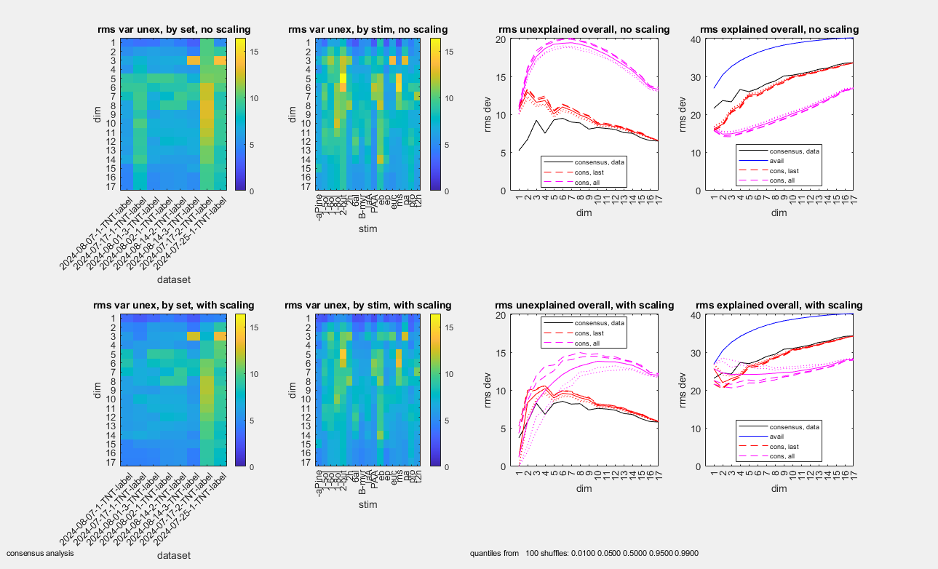

TNTin-nolabel:

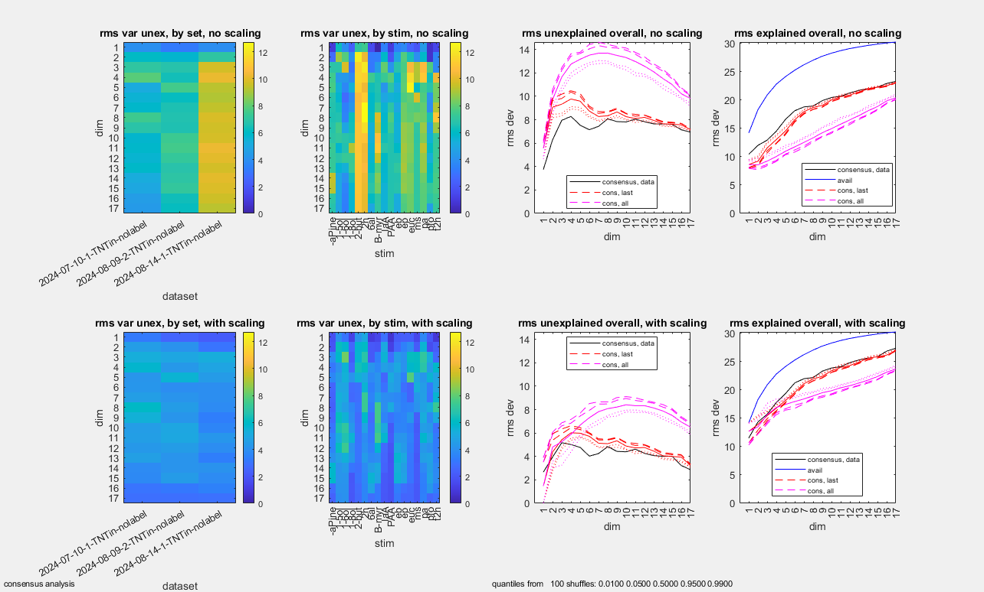

TNT-nolabel

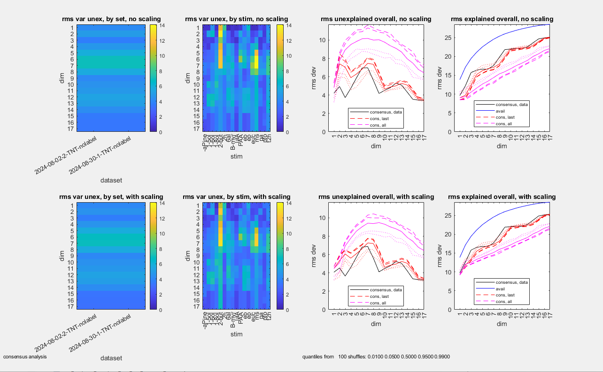

TNTin-label:

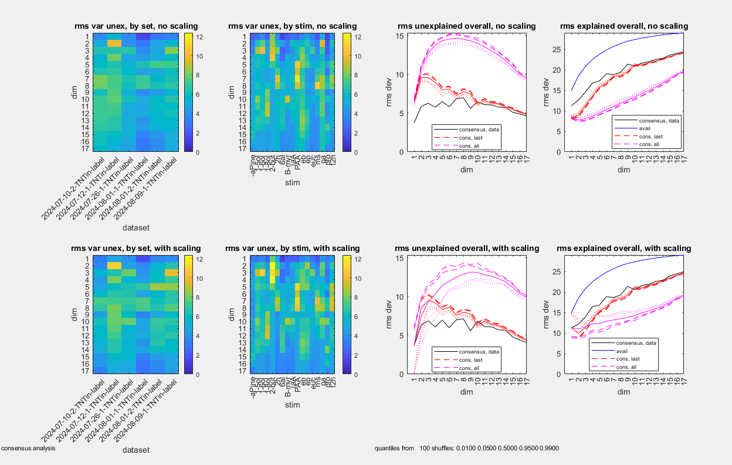

All control conditions pooled (plots/kc-TNT3c_align_stats_13Nov24.txt->fig)

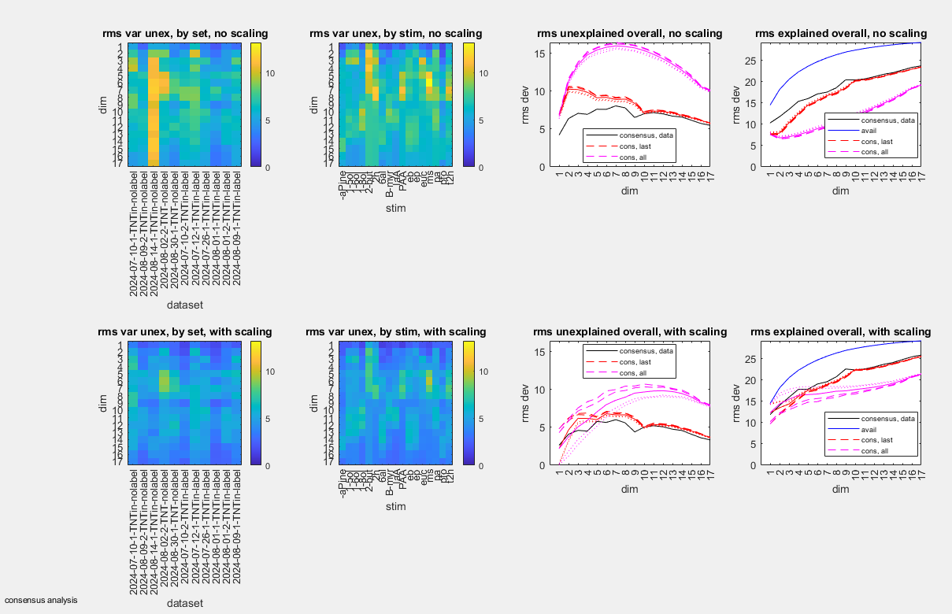

### Model-free comparison of TNT label with TNT3c, and among the three kinds of controls

This is a model-free analysis (no geometry assumed), showing that the odor space for TNTlabel is different than that of the pooled controls, TNT3c, and that the odor spaces for the three kinds of controls that make up TNT3c are not statistically distinguishable.

plots/psg_align_vara_demo_29Nov24.txt invoking psg_align_vara_demo.m

Each fly’s dataset is separately embedded (trial-averaged z-scores, mean not subtracted, pca), and then Procrustes consensus alignments are carried out, both within subsets of conditions, and across subsets of conditions (global).

First analysis is tntlabel (one condition, 8 preps) with tnt3c (all controls, 11 preps). Variance to global consensus and variance to within-subset consensus are computed, and variance to within-subset consensus for 500 shuffles. Across all embedding dimensions [1-17], the within-group variance is less than the 0.01 quantile of the shuffles.

plots\psg_align_vara_TNTlabel-TNT3c_29Nov24.fig.

Top row does not allow scaling in making the consensus (preferred), bottom row allows scaling.

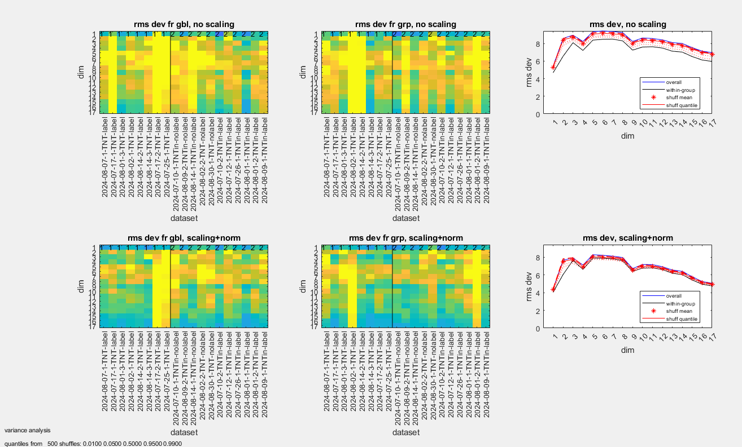

Second analysis compares the three kinds of controls: TNTin-nolabel(3 preps), TNT-nolabel (2 preps), TNTin-label(3 preps). Across all embedding dimensions [1-17], the within-group variance is near the mean of the the shuffles.

plots\psg_align_vara_TNT3c-within_29Nov24.fig

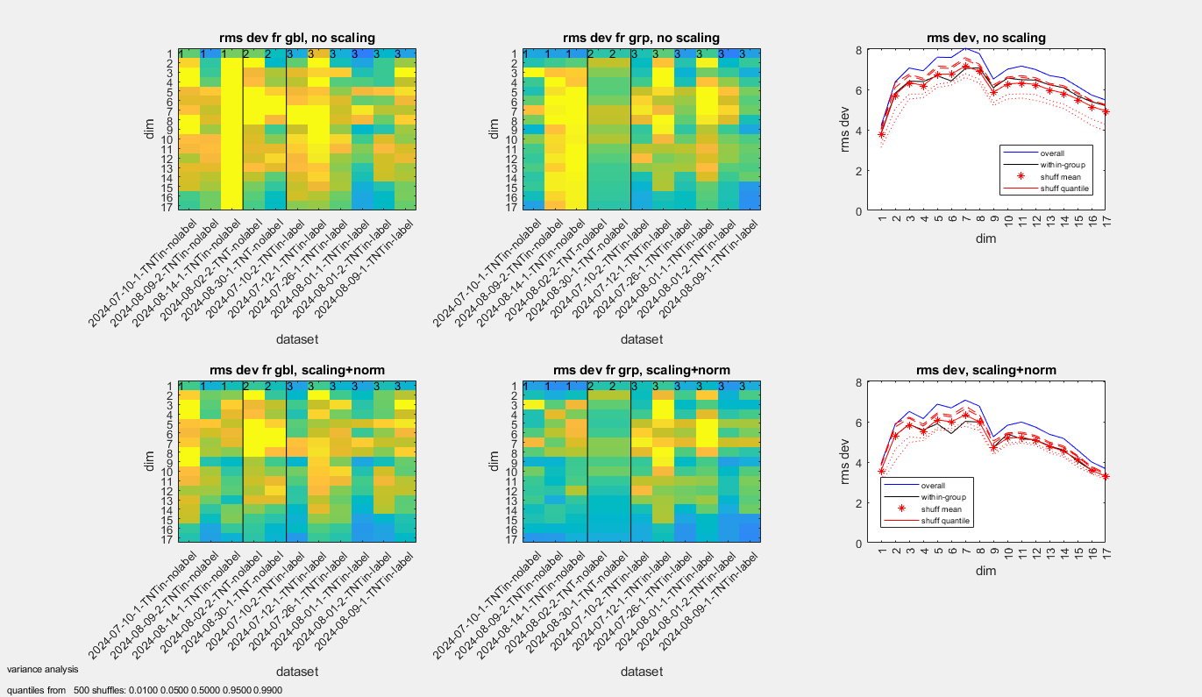

A visualization is to create the consensus space (by Procrustes) within each of the four kinds of treatments, and then to align these consensuses in a common space: plots/tnt_4cond_consensus_03Nov24.fig: note that the RED deviates from more from the three control conditions (blue, cyan, magenta) than their deviation from each other.

RED is TNT-label consensus; Controls: Blue is TNTin-nolabel consensus, Cyan is TNT-nolabel consensus, Magenta isTNTin-label consensus; Black is centroid of the four consensuses

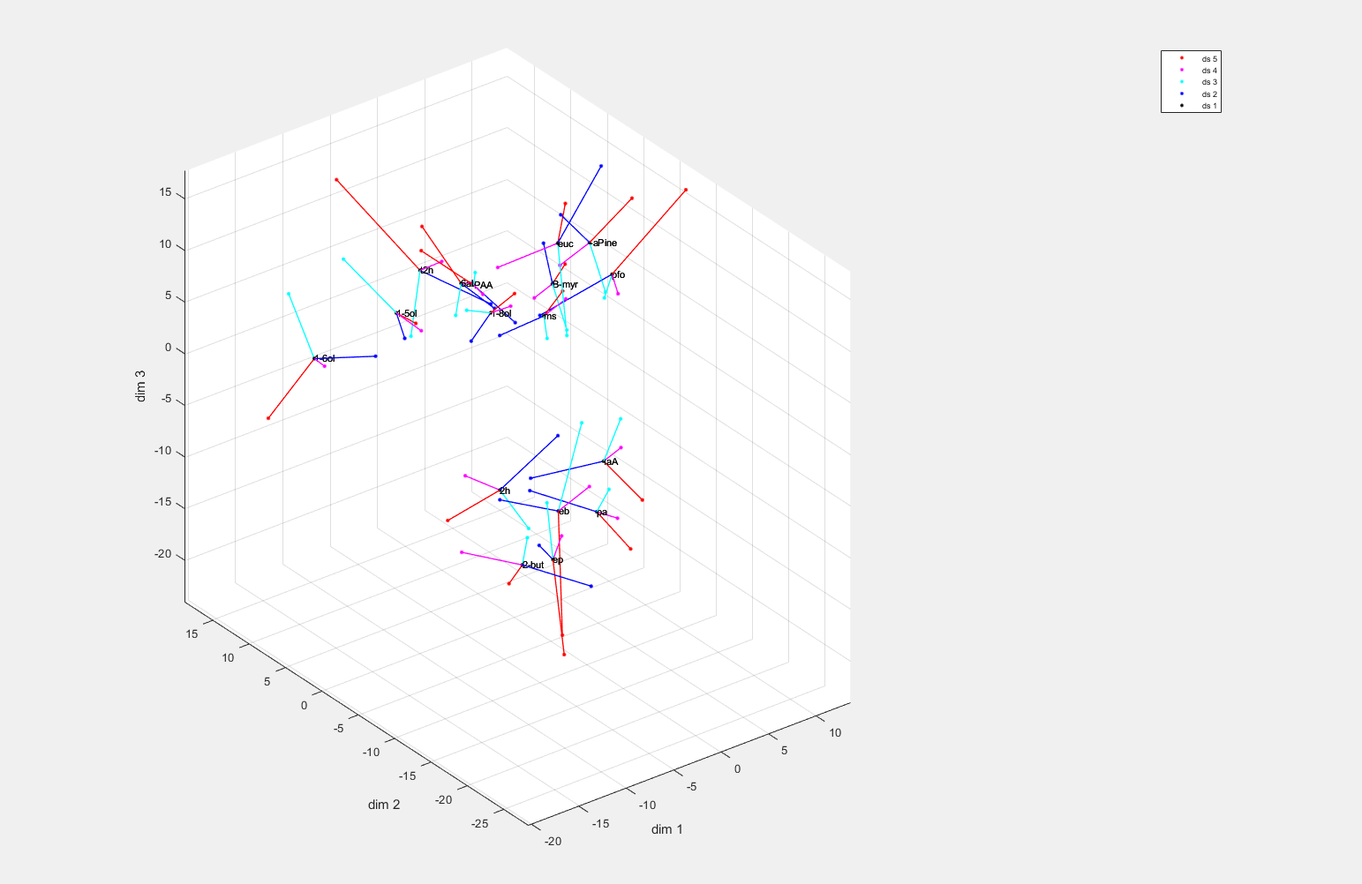

Another visualization, looking at each prep from the three kinds of controls, and their consensus

Plots/kc-TNT3c_process_13Nov24.txt->fig

Blue: 6 preps, tntin-label; green, 2 preps, tnt-noloabel; red: 3 preps, tntin-nolobel; black is consensus. No systematic segregation by color..

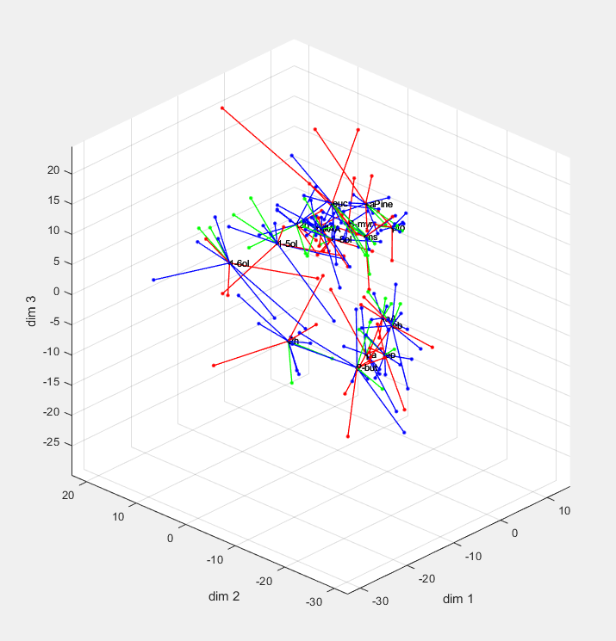

### Global geometric model of effect of inhibition: best fit by an affine transformation

The bottom line here is that a linear transformation with gain changes (“affine transformation”) that vary with direction is a better model than a uniform gain change, and that other models that contain the affine model (projective transformation or piecewise affine transformation) do not provide a better fit, when model complexity is taken into account. OTOH even the affine transformation leaves substantial variance unexplained.

Data from each of the 8 TNTlabel preps is embedded as above (trial-averaged z-scores, standard PCA, no mean subtracted), and same for the 11 control preps.

psg_geomodels_run_TNT_label_TNT3c_ConsensusNoScale.txt of 18Nov24, running psg_geomodels_run, and producing plots/tnt_label_tnt3c_consensus_noscale* of 18Nov24. (“noscale” means that no scaling between datasets was allowed in forming the consensus)

Numerical results saved in psg_geomodels_run_TNT_label_TNT3c_ConsensusNoScale.mat.

Here and below, “ref” dataset is the control, “adj” dataset is inhibition-removed, and we examine various transformations from the adj dataset to the ref dataset

The quantity “d” is standard: it is the sum of the squares of the residuals, divided by the sum of the squares of the distances of the data points from their centroid. So a model that maps everything to the centroid will yield a d=1, a model that is perfect has d=0.

#### Overview

tnt_label_tnt3c_consensus_noscale_procrustes_affine_summary.fig. This figure and the ones below plot “d”, the fractoin of the variance explained, for a series of models, as a function of the dimension used to model the adj (tntlabel) space and the ref (tnt3c) space. Procrustes-noscale means that no change in overall gain is allowed between the two spaces; Procrustes_scale allows an overall gain change but it must be uniform in all directions; affine_offset is our affine transformation; and the projective and pw=piecewise affine. The big and consistent drop is between Procrustes_scale and affine_offset, across 3,4, d, and 6-d models.

(You don’t see “affine_nooffset” because it is covered by affine_offset; affine_offset allows a translational and affine_nooffset does not—but the shift is irrelevant since the PCA embedding ensures that both datasets have the same centroids.)

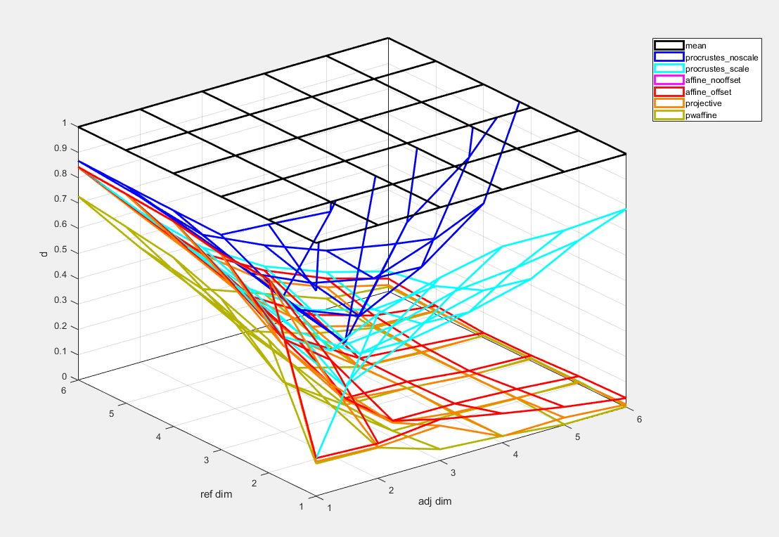

#### Statistics: comparison across model types

A shuffle test is used to show that models more complex than the affine model are not justified, despite the (slightly) greater variance explained.

These models are “nested” – projective contains affine which contains Procrustes_scale which contains Procrustes_noscale which contains mean, and similarly pwaffine contains affine, which contains….

To compare a base model with a more complex model in which it is nested: fit the dataset with the base model, and then shuffle (permute across stimuli) the residuals, to create a new surrogate “ref” space. Then refit the more complex model to the surrogate data. If the improvement is just due to model complexity, then the improvement in fitting the surrogate data with the more complex model should be comparable to the improvement in fitting the original data; if the improvement is real, then the original data will have lower residuals than the surrogate. This was done for 100 shuffles, and significant improvement declared and shown by asterisk if the original data showed an improvement more than 95% of the surrogates. (This is done two ways: using the original data as the denominator for d, or the shuffled data – but results are nearly identical. In the figures, significance with original data denominator is +, with surrogate data denominator is x, and both are a superposition – which is nearly always what happens.)

Figures also from psg_geomodels_run_TNT_label_TNT3c_ConsensusNoScale.txt of 18Nov24

Affine is better than Procrustes with scale: plots\tnt_label_tnt3c_consensus_noscale_procrustes_noscale_vs_scale.fig

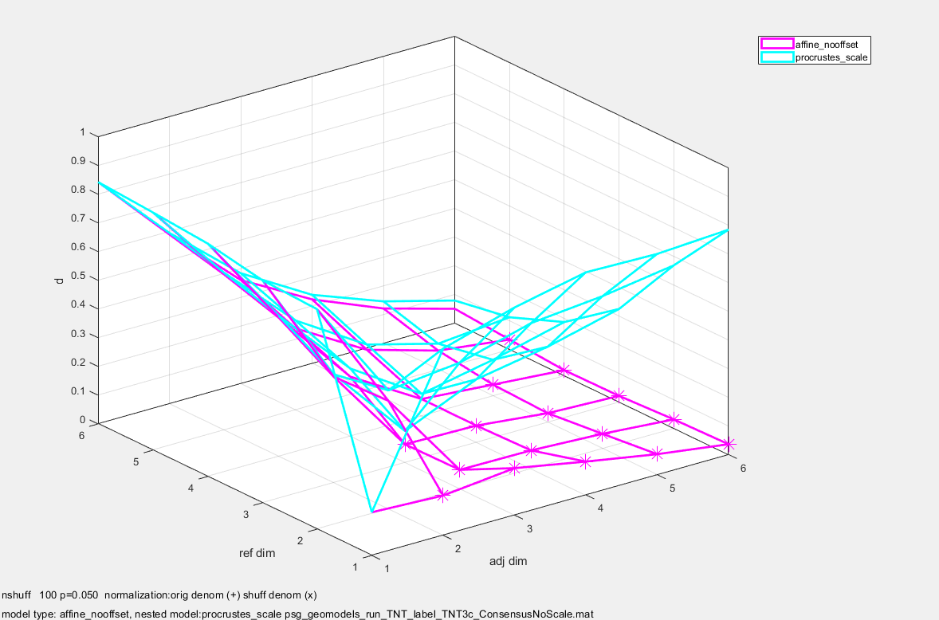

Projective vs. affine: minimally better for some combinations of dimensions but not robustly. plots\tnt_label_tnt3c_consensus_noscale_affine_vs_projective.fig

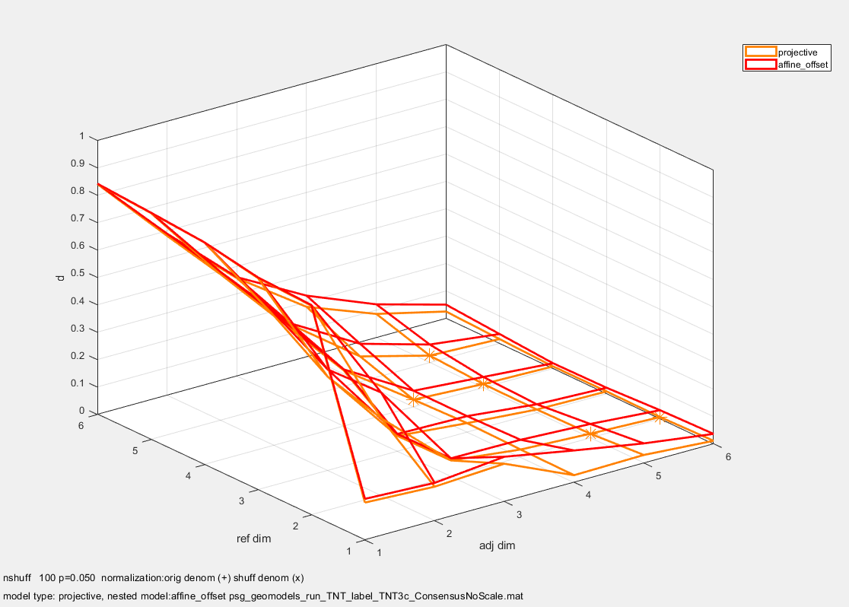

Piecewise affine: also better than affine , statistically, but minimally so. Note, this figure is revised tnt_label_tnt3c_consensus_noscale_affine_vs_pwaffine_revised.fig, original had an indexing bug, but seems to have had no effect.

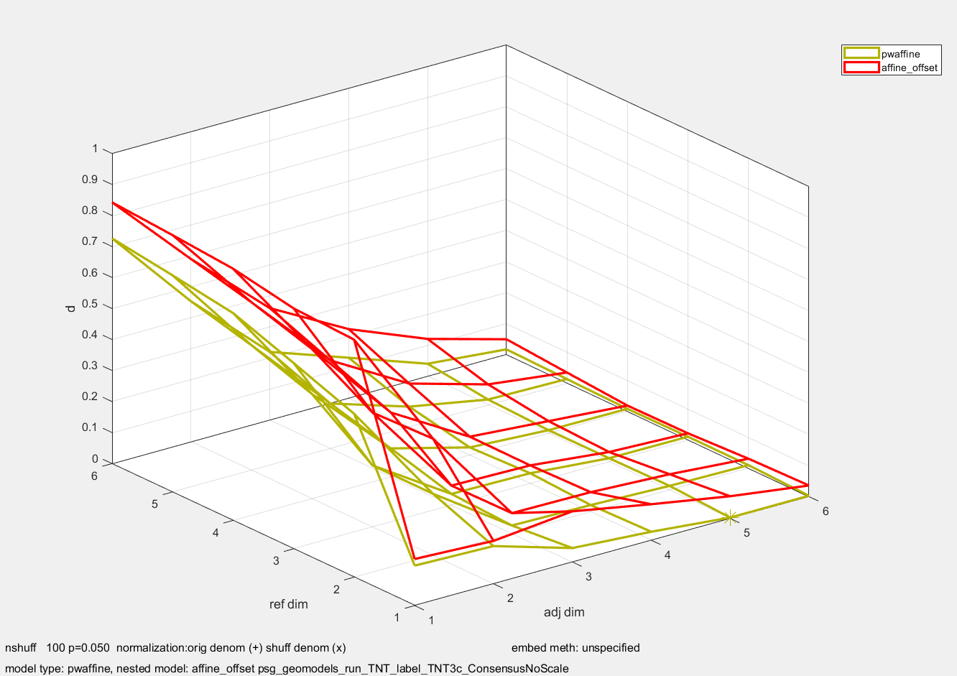

#### Statistics: comparison across dimensions

(I think this part is inessential) One can use a similar strategy for looking at number of relevant dimensions: a model from 4D adj space to 4D ref space contains a model of the same type from 3D adj space to 4D ref space.This analysis is below, for affine and projective. Generally, it shows that 3,4, and 5-d models are worth the complexity.

plots\tnt_label_tnt3c_consensus_noscale_affine_NestByDim.fig

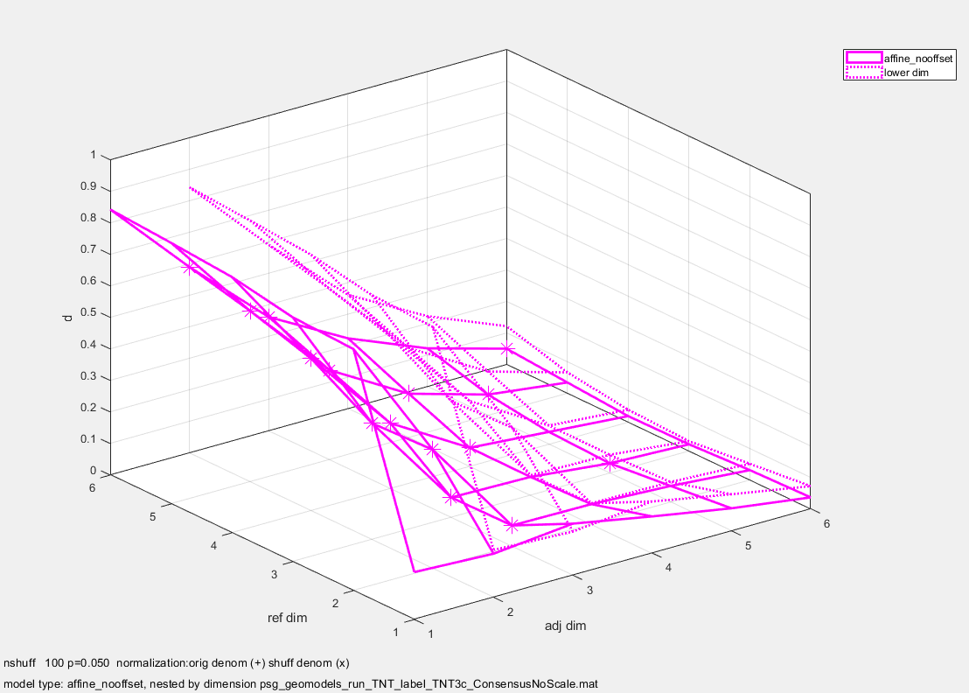

plots\tnt_label_tnt3c_consensus_noscale_projective_NestByDim.fig

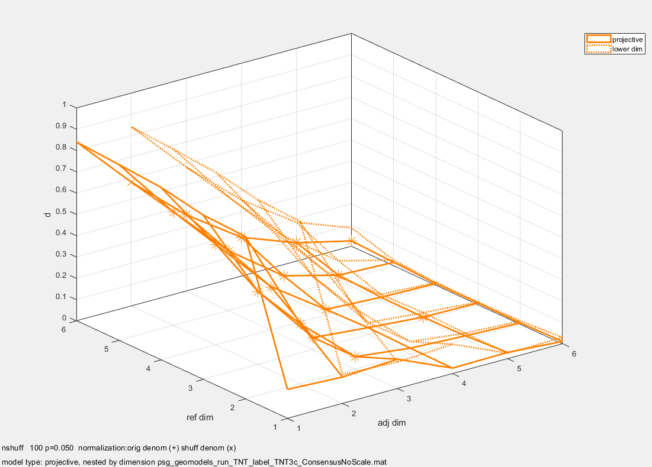

#### Fraction of variance explained

Table below corresponds to the diagonal values in the above summary plot

load('C:\Users\jdvicto\Documents\jv\OlfNav\HongLab\psg_geomodels_run_TNT_label_TNT3c_ConsensusNoScale.mat')

whos

Name Size Bytes Class Attributes

results 6x6 480085500 cell

>> results{1,1}.model_types_def

ans =

struct with fields:

model_types: {'mean' 'procrustes_noscale' 'procrustes_scale' 'affine_nooffset' 'affine_offset' 'projective' 'pwaffine'}

mean: [1×1 struct]

procrustes_noscale: [1×1 struct]

procrustes_scale: [1×1 struct]

affine_nooffset: [1×1 struct]

affine_offset: [1×1 struct]

projective: [1×1 struct]

pwaffine: [1×1 struct]

Columns of the table are residuals for each of the seven model types. Affine is bolded black. Procrustes with scaling is bolded blue.

>> for k=1:6;disp(k);disp(results{k,k}.d');end

1 1.0000 0.8109 0.1503 0.1503 0.1503 0.1368 0.1290

2 1.0000 0.9617 0.4130 0.3765 0.3765 0.2826 0.1987

3 1.0000 0.2832 **0.1096** 0.0633 **0.0633**  0.0562 0.0364

4 1.0000 0.2253 **0.0771** 0.0590 **0.0590**  0.0265 0.0245

5 1.0000 0.2123 **0.0900** 0.0659  **0.0659**  0.0254 0.0171

6 1.0000 0.1836 **0.0783** 0.0495 **0.0495** 0.0243 0.0169

>>

Also, extracted the residuals as a function of adj and ref dimension

Bold corresponds to the bolding above; row is ref dim, col is adj dim

>> for ir=1:6;for ia=1:6;d(ir,ia)=results{ir,ia}.d(5);end;end

>> d

d =

0.1503 0.1384 0.1635 0.1160 0.0715 0.0359

0.7661 0.3765 0.0660 0.0634 0.0508 0.0307

0.7754 0.3691 **0.0633** 0.0581 0.0310 0.0210

0.8117 0.4825 0.2072 **0.0590** 0.0390 0.0188

0.8284 0.5416 0.2838 0.1389 **0.0659** 0.0339

0.8425 0.5895 0.3607 0.2228 0.1209 **0.0495**

>>

Note that although the affine embedding is an improvement over Procrustes, it only accounts for about 30% more of the variance.

#### Visualization of the geometrical models

This is a visual comparison of the geometric models. It confirms that the affine model is better than a simple scaling and rotation, but also shows that the deviations do not have an evident pattern.

Calculations done with psg_consensus_demo_29Sep25.txt (creating transformed data files in data/kc_tnt/ hlid_odor17_coords_tnt-3c-model_[model_name][-rot].mat, with models of all dimensions), and then psg_coord_pipe_proc_29Sep25.txt, with the 3-dimensional model.

plots\kc-tnt-3c-simplemodels_dim3.fig: magenta is control. Other colors show progressive increases in model complexity: black is no model (just rotate to best alignment), blue adds an overall scale, and cyan is the affine model. They get closer to the magenta, but still deviate, with no obvious pattern.

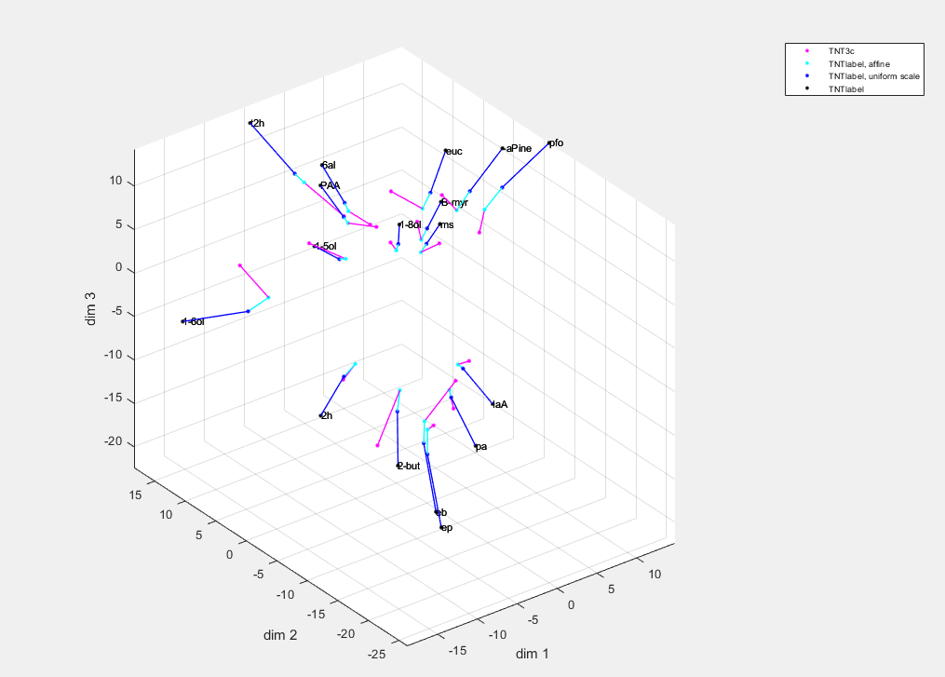

This plot adds the more complex models: projective as orange, piecewise affine as red, also connected to control. Visually,there’s no systematic improvement over the affine model (cyan).

(\plots\kc-tnt-3c-allmodels_dim3_reorder.fig, based on \plots\kc-tnt-3c-allmodels_dim3.fig, but redone to match the above w.r.t. colors). Could also plot with half-colored lines, see psg_consensus_demo_03Oct25.txt and \plots\kc-tnt-3c-allmodels_dim3[t|v].fig)

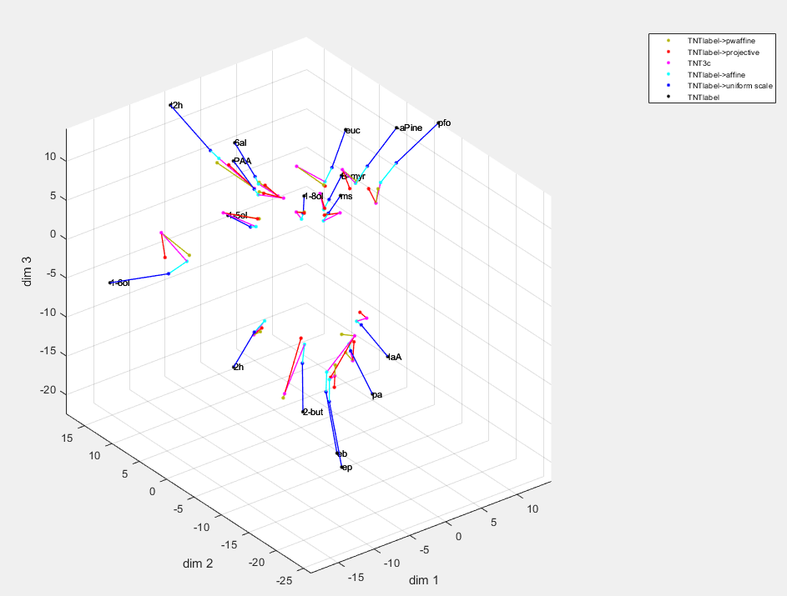

### How anisotropic is the transformation?

#### Background: the principal axes of the transformation

We model the transformation y=xA, where the row vectors x are the coordinates in the “adjusted” space (i.e., inhibition turned off), the row vectors y are the coordinates in the “reference” space. Since it is a linear transformation, it takes a sphere in the adjusted space to an ellipsoid in the reference space. We ask, what directions in the adjusted space are most, or least, magnified by the transformation? If suffices to consider how the transformation acts on unit vectors,i.e., points on a sphere in the adjusted space.

Above equation implies, yyT=(xA)(xA)T=xA ATxT. This is extremized when x is an eigenvector of AAT. Similarly, the directions in the reference space in which the transformations have maximal or minimal gain are given by y=xA, for the eigenvectors of A. These are necessarily eigenvectors of ATA, since, if xAAT=kx, then y(ATA)=xA(ATA)=x(AAT)A=kxA=ky.

Since AAT and ATA are both symmetric, their eigenvetors are necessarily orthogonal. Below, referring to the eigenvectors as the “principal axes of the transformation.”

The expansion factors are the square roots of the eigenvalues, and are displayed below.

So there are two natural sets of axes in the kc-tnt or kc-3c odor space: the principal components in that space (independent of any transformation), and the principal axes of the transformation between them. In the plots below, we plot these principal axes in terms of how the odors project onto them, i.e., the directions of the eigenvectors in odor space. Since only the directions matter, the heatmaps for the coordinates are plotted so that the maximum absolute value is 1.

Main analysis is via hlid_majaxes.m, in hlid_majaxes_TNT_label_TNT3c_ConsensusNoScale.txt of 19Nov24. hlid_majaxes_TNT_label_TNT3c_ConsensusNoScale_justAffineOffset.pdf.

#### Analyses

Showing here the analyses for the 3-dimensional, 4-dimensional, and 5-dimensional fits. Top panels are the principal components of the individual spaces (i.e., the directions that explain the most variances in the space, Independent of the transformation). Bottom panels show the eigenvectors and the gains. If the affine model were perfect, the eigenvectors in the two spaces would be identical – since they would completely explain the transformation. They are not … because the positions of the 17 odorants in each of the spaces is not where they would be if y=Ax. OTOH, any similarity of the directions in the lower panels and the directions in the upper panels is not a mathematical consequence; it would mean that the principal axes of the individual spaces are similar to the principal axes of the transformation.

Overall, 3D, 4D, and 5D models are consistent with each other, and show approx. a 1.5:1 difference in the magnification between the greatest and the smallest direction.

**3D model:** Principal directions in lower panel are quite similar (eiv 1 and 3 are flipped in the ref space). Scale factors – here labeled eiv -- are 0.96:0.63:0.56, approx. 1.73:1.13:1. (Page 3 of hlid_majaxes_TNT_label_TNT3c_ConsensusNoScale_justAffineOffset.pdf)

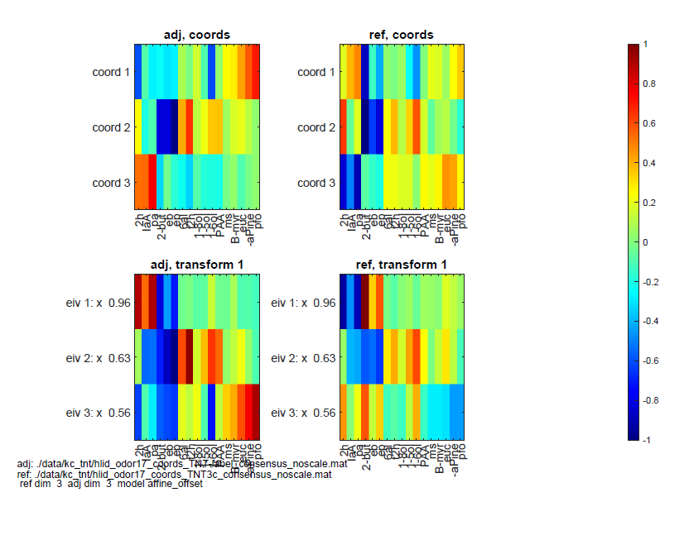

**4d model:** Reasonable agreement between the eigenvalues in the lower panel. Magnif ratios 0.84:0.80:0.70:0.59, or

1.42:1.36:1.19:1. First and last eigenvectors match up with first and last eigenvectors of 3d model. (Page 7 of hlid_majaxes_TNT_label_TNT3c_ConsensusNoScale_justAffineOffset.pdf)

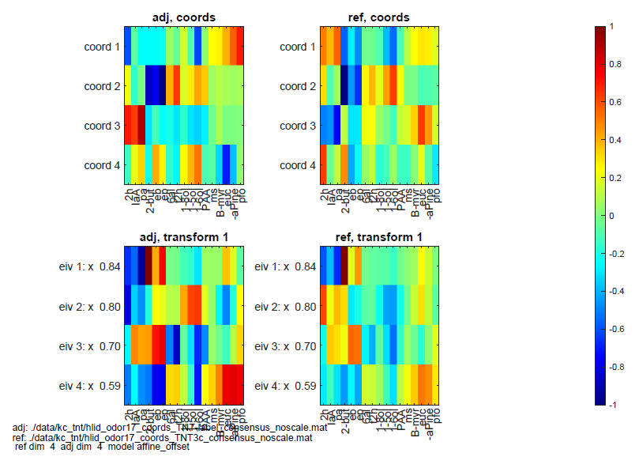

**5d model:** Reasonable agreement between the eigenvalues in the lower panel. (Page 8 of hlid_majaxes_TNT_label_TNT3c_ConsensusNoScale_justAffineOffset.pdf) Eigenvctors still agree across adj and ref; prinxipal axes of transformation similar to bove but first and third eivs both have a resemblance to first eiv of 4d model, and eivs 4 and 5 both have a resemblance to fourth eiv of 4D model. (This could be quantified by dot-products if needed).

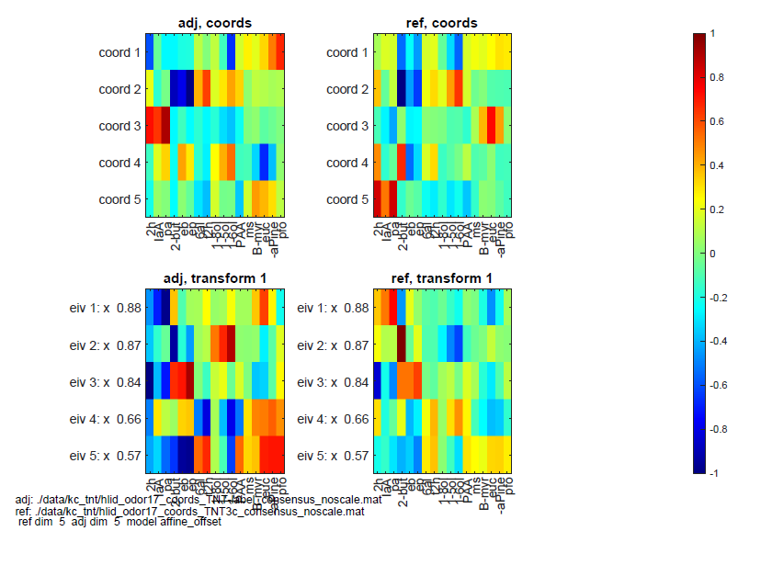

**6d model:** Reasonable agreement between the eigenvalues in the lower panel. (Page 9 of hlid_majaxes_TNT_label_TNT3c_ConsensusNoScale_justAffineOffset.pdf) But now, the first eig of transformation looks different. So one has to start doubting the robustness.

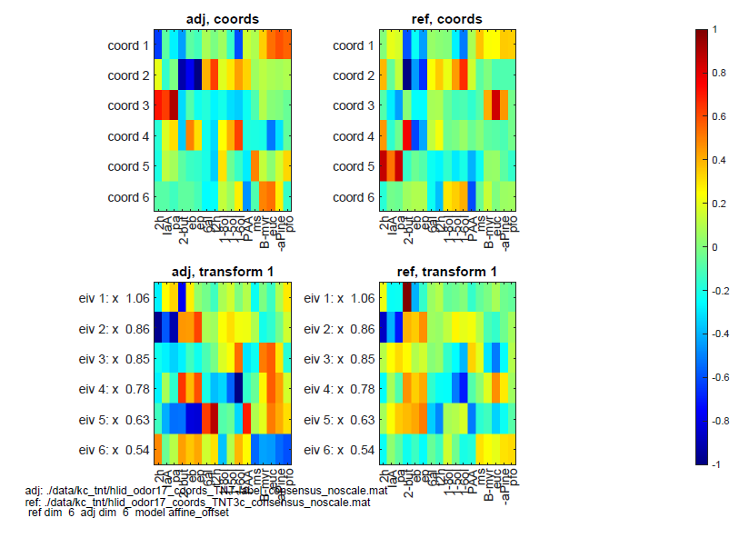

#### Numerics

Compares these directions quantitatively. See hlid_majaxes_comparedims_demo.[m,txt].

For example, the 4-d section

The transformation itself does not seem to have any relationship to the PC’s.

The projections (principal axes of the transformation) are close-to-orthogonal coords in terms of projections of the odors. This is expected, in that the axes must be orthogonal in PC space, and the odors sample the PC space fairly well.

The principal axes in the adj space are similar to the principal axes in the ref space, which is a check that the transformation is a reasonable model.

The axes in the 4d space are similar to the axes in the 3d space.

dimension 4: transformation from adj to ref, coords are pcs in each space

0.2498 -0.1020 0.2716 -0.4944

0.1505 0.7122 0.0934 0.0522

0.6666 0.0078 -0.4325 0.1339

-0.1869 0.2673 -0.4484 -0.5398

dot-products of projections with themselves in adj

1.0000 0.2149 0.2797 0.0273

0.2149 1.0000 -0.2050 -0.1030

0.2797 -0.2050 1.0000 -0.3226

0.0273 -0.1030 -0.3226 1.0000

dot-products of projections in adj with lower-dim adj space

**-0.9526** -0.2817 -0.0097

-0.4824 0.2472 -0.0533

-0.2489 **-0.9740** -0.1574

-0.0090 0.5017 **0.9735**

dot-products of projections with themselves in ref

1.0000 -0.1609 0.2354 -0.0052

-0.1609 1.0000 0.1655 0.0476

0.2354 0.1655 1.0000 -0.2968

-0.0052 0.0476 -0.2968 1.0000

dot-products of projections in ref with lower-dim ref space

**0.9702** -0.2732 0.0752

-0.3896 -0.3091 0.0951

0.2143 **-0.9485** 0.0918

0.0011 0.4924 **-0.9429**

dot-products of projections in adj space (rows) with projections in ref space (cols)

**0.9733** -0.2086 0.2705 0.0264

0.2092 **-0.9705** -0.1982 -0.0997

0.2723 0.1989 **0.9668**  -0.3123

0.0265 0.0999 -0.3119  **0.9681**

#### Auxiliary analyses

Parallel analysis for the two pieces of the piecewise affine transform, in hlid_majaxes_TNT_label_TNT3c_ConsensusNoScale.pdf (from same script as above), and, analysis of TNTlabel and TNT-inLabel (only one control), in hlid_majaxes_TNT_label_TNTin_label_ConsensusNoScale.txt of 19Nov24, with plots saved as hlid_majaxes_TNT_label_TNTin_label_ConsensusNoScale.pdf.

Analysis of the principal axes of the projective transform does not make much mathematical sense.

### Non-standard embeddings (also ORN and kc_soma datasets)

Bottom line: nonstandard embeddings also show an anisotropic transformation. They explain slightly more of the variance, but they are also “compressive” (since they effectively map all of the responses to the surface of a sphere, so magnitude information is lost.)

#### Setup

Even though the affine model accounts for >90% of the variance, and ~75% of the variance not explained by a simple rotation, it fails to explain the decoding results. However, note that even though it does explain a large fraction of the variance, the model errors are comparable to the distances between stimuli, and also, to individual differences between preps. So perhaps this is not so surprising.

So we looked at geometric models after alternative embeddings, i.e., multidimensional scaling of other distances. This included distances based on cosines between responses normalized to unit length:

“cosine” family -- The cosine similarity (1-cosine), the arc length distance (the angle between the vectors), and the chord distance (Euclidean distance between the endpoints). These are calculated based on the dot-product between the unit vectors. Cosine(angle)=dot-product; arc length distance=cos-1(dot product), chord distance=sqrt(2)*sqrt(1-dot product).( (Note that the cosine distance is not a metric, but its square root, proportional to the chord distance, is a metric).

These were calculated from the z-scores as is, or, after subtracting the mean across stimuli of the raw scores.

Also, a family of distances based on Pearson correlation – where the response vector (across KC’s) is first mean-subtracted, before computing the dot products.

All calculations done with trial-averages only – to reduce noise for the correlation-based measures and to get only one value for each pair of odorants.

All distances were then normalized so that, for each distance type, the RMS distance = 1.

Parallel computations for PCA and SVD – the latter agree if mean is first subtracted from the responses.

This analysis was carried out by hlid_rastim_mds_coords_demo.m, via hlid_rastim_mds_coords_04Nov25.txt, and a consensus space created within the label, or within the control, datasets, producing

\data\mds_consensus-embeddings_orn_kchlid_consensus_coords_kc_[tntlabel|tnt3c]_[embedding][-ms].mat

-ms in file name if mean is subtracted from z-scores. (soma_nls datasets also analyzed.)

here, “embedding”=

euc_svd: principal components analysis

euc_mds: multidimensional scaling

cos_sim: cosine similarity

cos_ang: cosine, angle distance

cos_chord: cosine, chord distance

pear_sim: Pearson similarity

pear_ang: Pearson angle distance

pear_chord: Pearson chord distance

Parallel calculations also done for orn_terminals and kc_soma_nls, in same directory.

These embeddings are compared with each other – not dramatically different though the Euclidean embeddings look a little separate:

psg_align_stats_demo_30Jan26: NOT mean subtracted, all 8 embeddings, making

psg_align_stats_demo_30Jan26_[tntlabel|tnt3c|kc_soma|orn_terminals].fig

psg_align_stats_demo_04Nov25: mean subtracted, all 8 embeddings, making

psg_align_stats_demo_04Nov25_[tntlabel|tnt3c|kc_soma|orn_terminals].fig

psg_align_stats_demo_05Nov25: mean subtracted, 6 embeddings, excluding Eucildean

psg_align_stats_demo_05Nov25_[tntlabel|tnt3c|kc_soma|orn_terminals].fig

This is psg_align_stats_demo_30Jan26_tnt3c.fig, note the yellow streaks on upper left, over euc-svd and euc-mds, showing the Euclidean embeddings differ from the consensus of the embeddings somewhat.

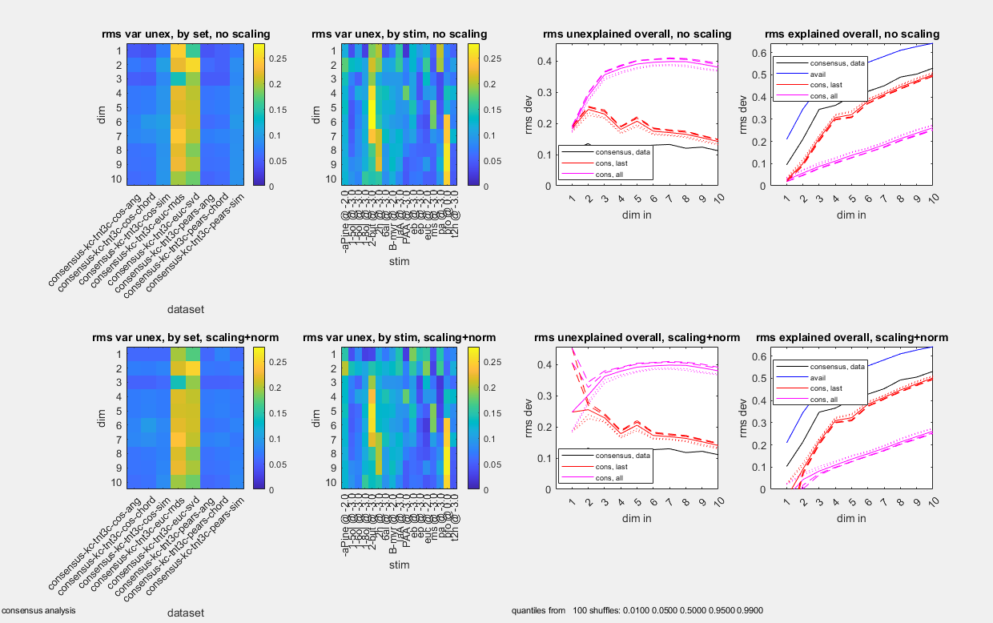

This is psg_align_stats_demo_30Jan26_tnt3**label**.fig, same pattern.

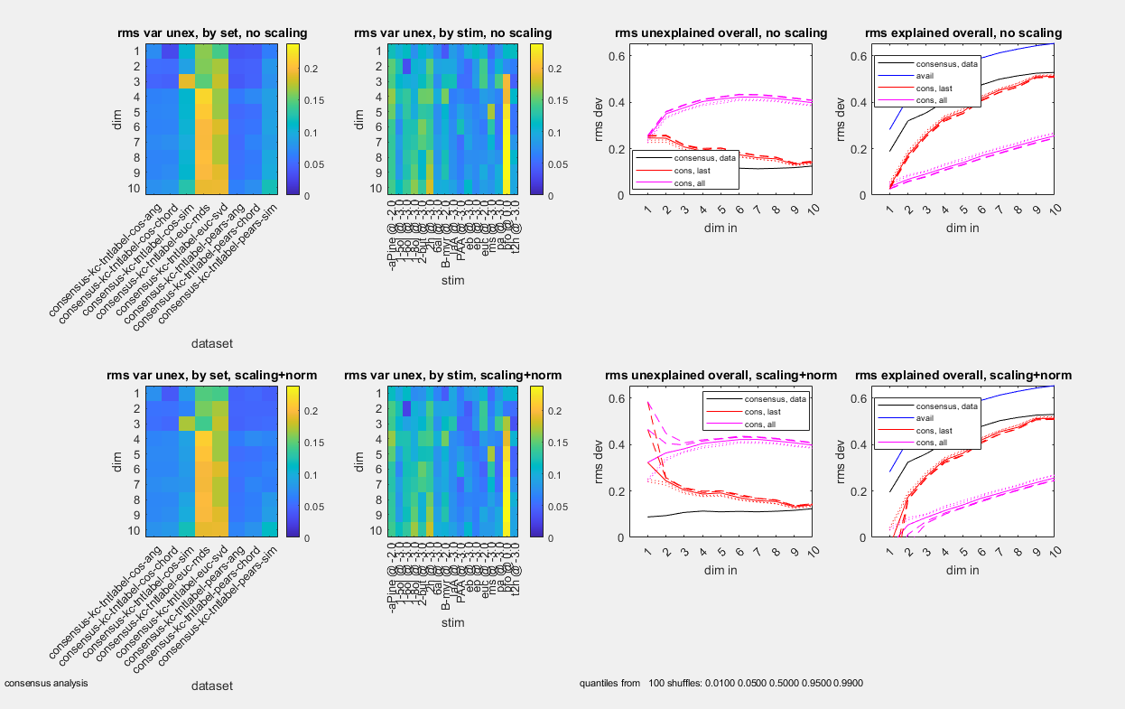

#### Quantitative comparison of the embeddings

No real difference in variance unexplained as a function of dimension, and statistical justification based on shuffle test for at least 5-6 dimensions.

**However, for a given number of dimensions, more there is more unexplained variance in ORN datasets than the three KC datasets (megamat, tnt3c, tntlabel).** This is more obvious in the plot of explained variance (lower of the two plots). In all cases, distances have been normalized to have an RMS of 1, for each embedding, and for each dataset.

hlid_rastim_mds_coords_summ.txt, running hlid_rastim_mds_coords_summ.m, creating

hlid_rastim_mds_summ_[unex|ex]var[-sm]_07Nov25.fig (unexplained variance, explained variance, without and with mean subtraction)

red are quantiles (lowest is 0.01) for shuffles, where the explained variance of the actual data is compared with the explained variance in surrogate datasets in which the lower dimensions are fixed, and the higher dimensions are shuffled among stimuli – showing that at leaseet 5-6 dimensions are justified by this criterion.. Pink shuffles all dimensions (a much easier hurdle)

Top row is orn dataset, then megamat, then tnt-3c then tntlabel. Eight columns are the eight embedding methods: PCA, MDS, cosine (similarity, angle, chord), Pearson (similarity, angle, chord),

hlid_rastim_mds_summ_unexvar_07Nov25.fig below. Black is data, red is shuffle-higher-dimensions,

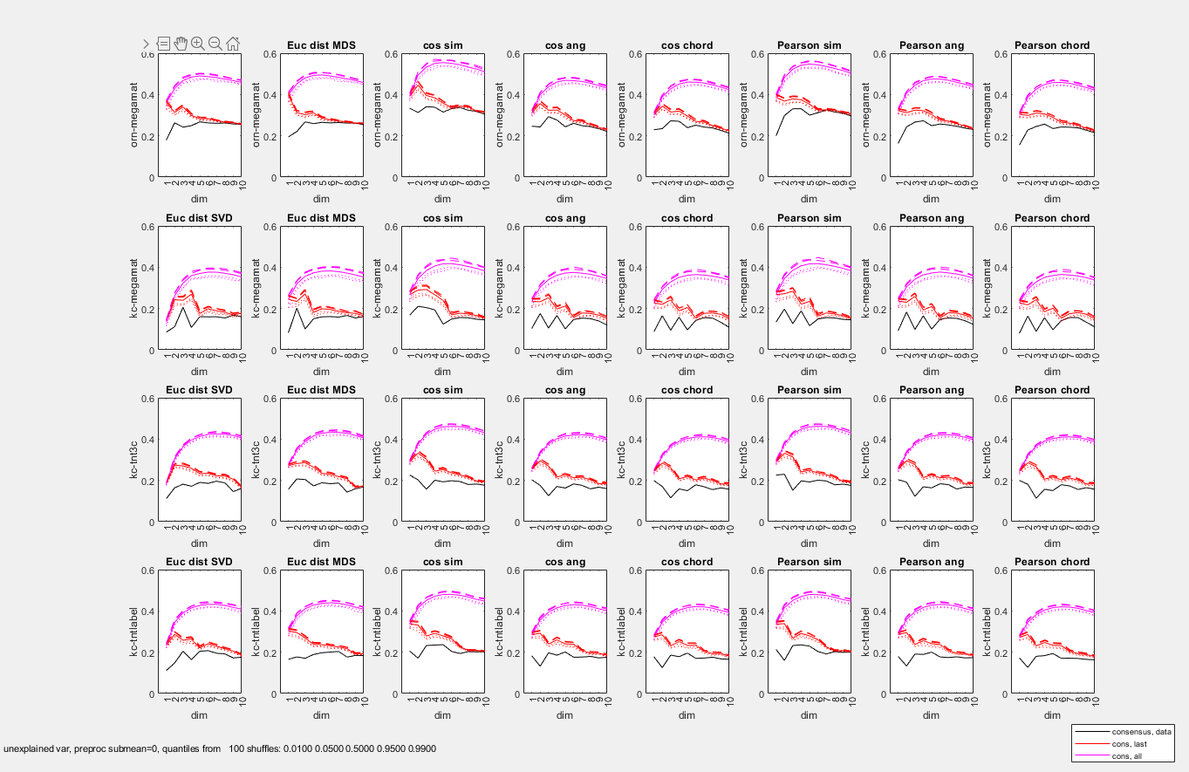

hlid_rastim_mds_summ_exvar_07Nov25.fig below [blue is available variance]

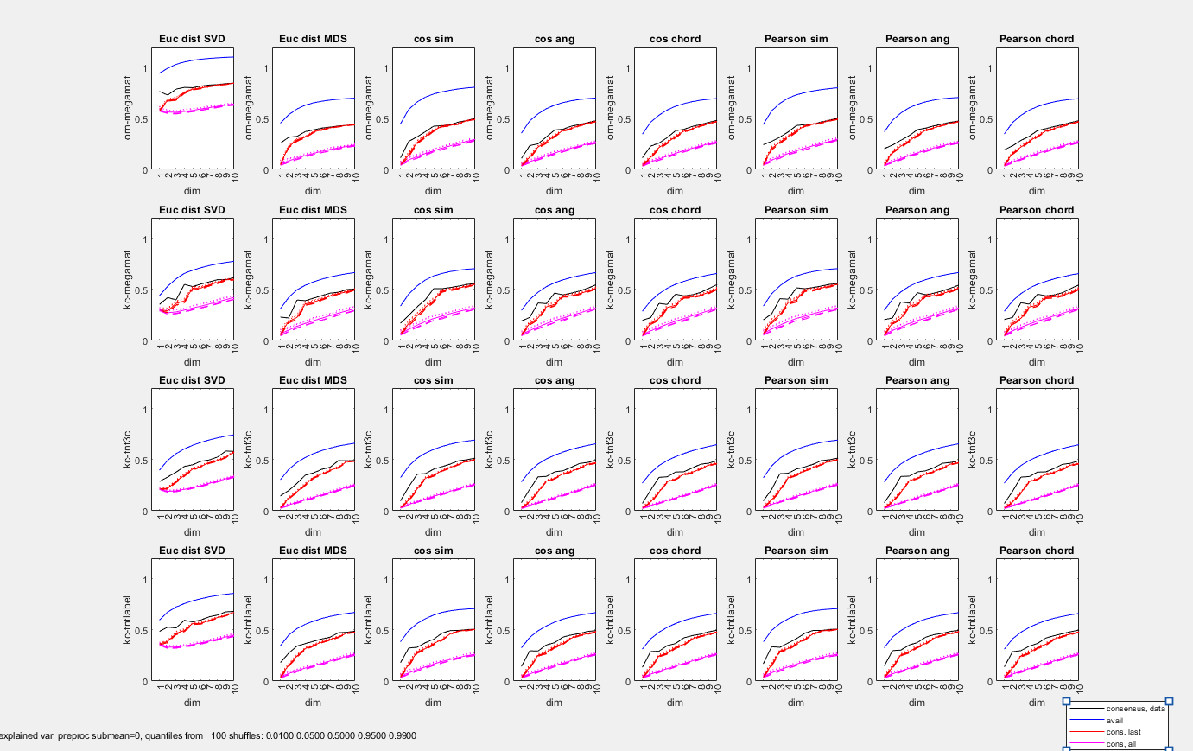

Comparison of fraction of explained variance as function of dimension, for each of the four datasets (red: ORN, black: KC-megamat, blue: KC-3c, cyan: KC-label)—showing ORN’s have more unexplained variance

8 columns are the 8 embeddings, top row is NOT mean subtracted, bottom is mean-subtracted

(hlid_rastim_mds_coords_summ2_07Nov25.txt running running hlid_rastim_mds_coords_summ.m, creating, plots\hlid_rastim_mds_summ2_07Nov25.fig)

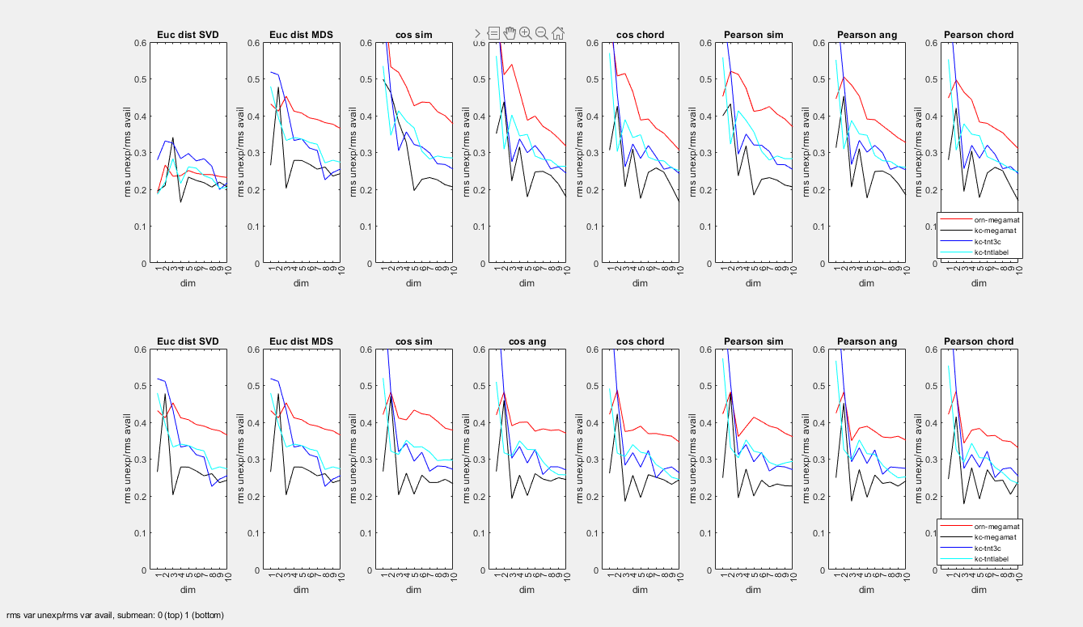

The greater unexplained variance also holds if one compares subsamples of three preps each (to take care of possible confound that different datasets had more preps). Plots as above, with dashed lines are same as the solids above (NOT subsampled), solid lines are resampled.

hlid_rastim_mds_coords_summ2s.txt, running hlid_rastim_mds_coords_summ2s.m, making plots\hlid_rastim_mds_coords_summ2s_sub3.fig)

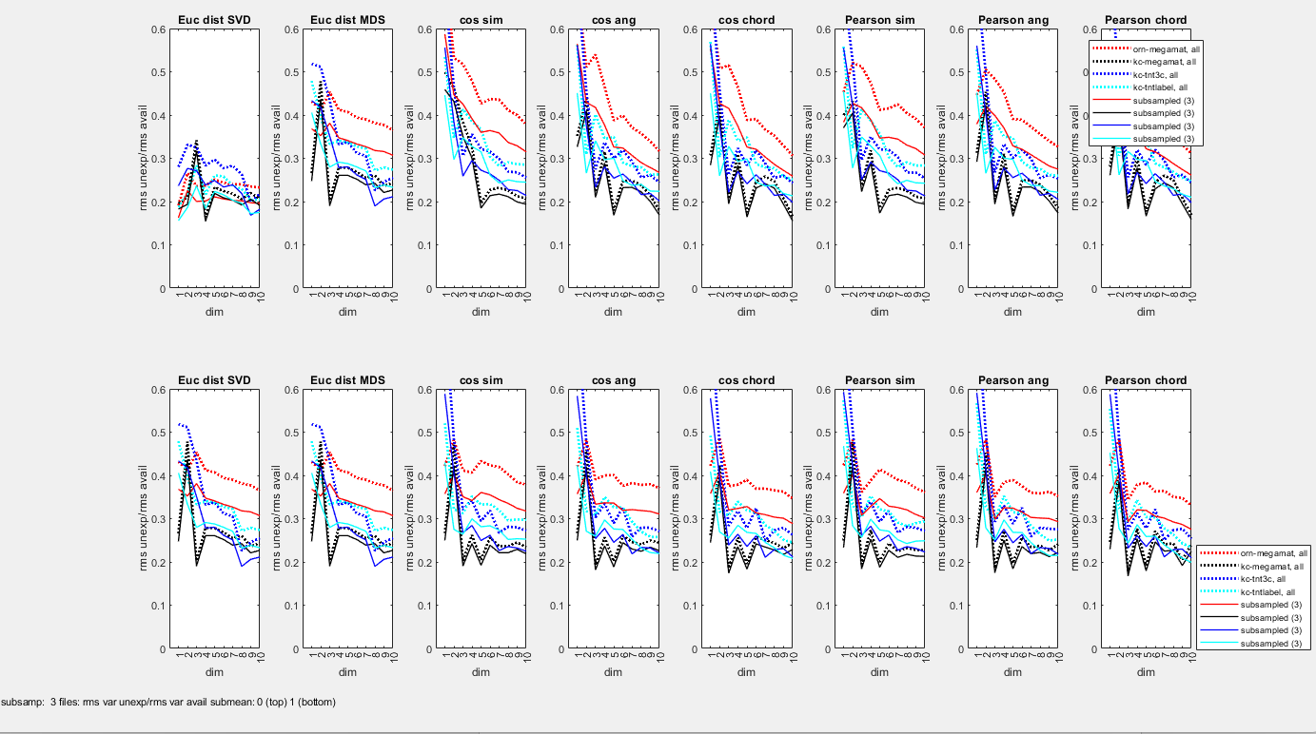

#### Participation ratio, “non-Euclidean” dimension:

As above, all of the alternative embeddings had a similar dependence of fraction of power explained as a function of dimension. Below top row, eigenvalues (variance explained at each dimension);this is without mean subtracted, for the TNT label. Colored lines are individual preps, solid black line is mean, dashed black line is median.

Lower right of plots: A standard measure of this is the “participation ratio”, which is the sum of the (eigenvalues^2) divided by (sum of the eigenvalues)^2, it is 1 if the first dimension explains everything, and 1/N if N dimensions are equally used. There’s a dip for the similarity measure – suggesting that responses are concentrated in a lower-dimensional space.

Lower left of plots: a measure of Euclidean-ness. For some of the nonstandard embeddings– the cosine similarity and cosine angle, Pearson simllarityh and Pearson angle – there is no guarantee that a Euclidean embedding will work. (Similarity measures are not metrics, and angles are metrics, but they are geodesics on the surface of a sphere). This means that embedding via multidimensional scaling could lead to negative eigenvalues, i.e., a hyperbolic embedding. The extent of this is measured by the “power ratio”, lower right below, which is the ratio of the total power in the positive (Euclidean) eigenvalues, divided by the total power in all the eigenvalues. It is very close to 1, even for the embeddings that could be non-Euclidean.

hlid_rastim_mds_kc-tnt3c_07Nov25.txt -> hlid_rastim_mds_coords_demo.m, reading raw data files, saved as pdf’s. PDF’s also include plots of the shuffle-based statistics for each embedding, again showing justification for >5 or 6 dimensions. Similar plots for TNT3c, and megamat, and ORN’s.

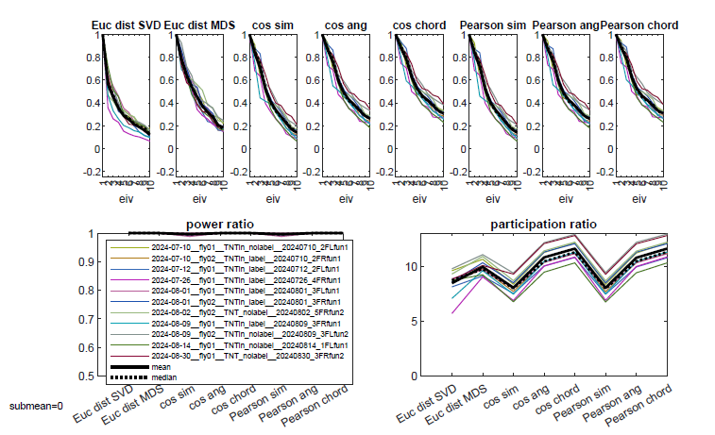

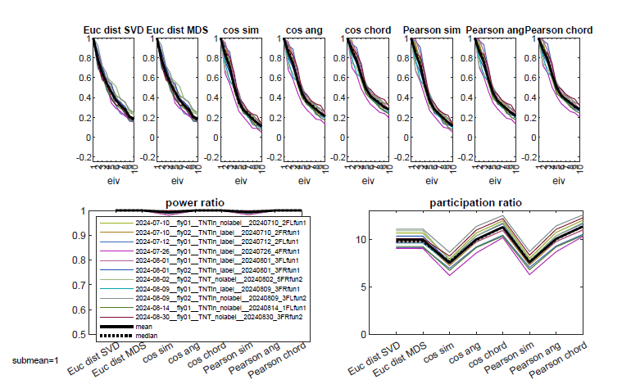

#### Graphical comparison of the embeddings

In first 3 dimensions, the nonstandard embeddings (cosine: red, Pearson: green) are a bit more spread out than Euclidean (black). All show the same three clusters (dim1,2,3, upper left). But in dim 4 (other plots), the Euclidean embeddings spread out.

Angle (triangle) and chord (square) are quite similar.

hlid_mds_coords_geomodels_01Dec25.txt running hlid_mds_coords_geomodels.m, making

hlid_mds_coords_geomodels_8embeds_tnt[3c|label]_[nosub|submean].fig (below: tnt3c, nosub mean)

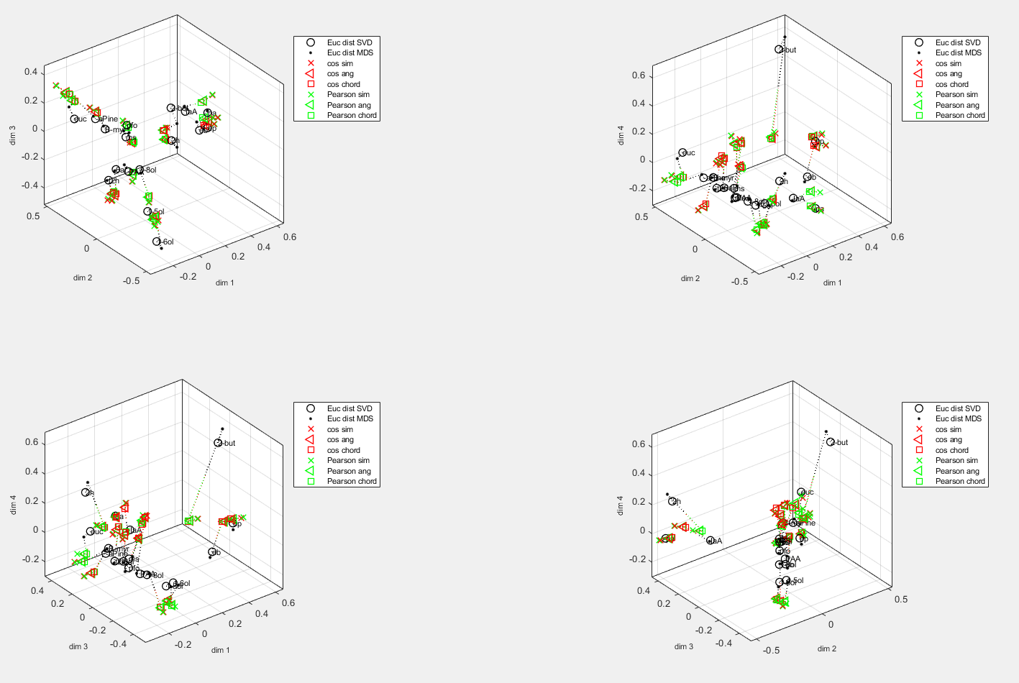

#### Transformation from TNTlabel to TNT3c

This is very similar to the standard embeddings.

Two sets of plots, both with hlid_mds_coords_geomodels.m:

hlid_mds_coords_geomodels_08Dec25.txt: hlid_mds_coords_geomodels_08Dec25_figs.zip – all 8 embeddings, models including piecewise affine, up to 7 dimensions, 20 shuffles

hlid_mds_coords_geomodels_09Dec25.txt: hlid_mds_coords_geomodels_09Dec25_figs – all 8 embeddings, does not include piecewise affine, up to 10 dimensions. 100 shuffles

Representative example: cosine angle, nosubtract mean

hlid_mds_coords_geo_7d_allmodels_cos_ang_nosub.fig

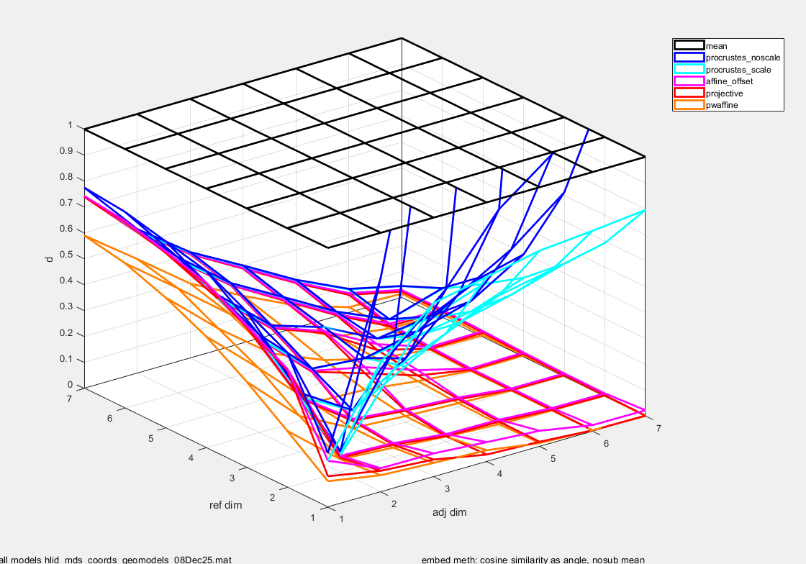

Affine is an improvement over Procrustes with scaling:

hlid_mds_coords_geo_7d_model-aff-offset-nested-proc-scale_cos_ang_nosub.fig

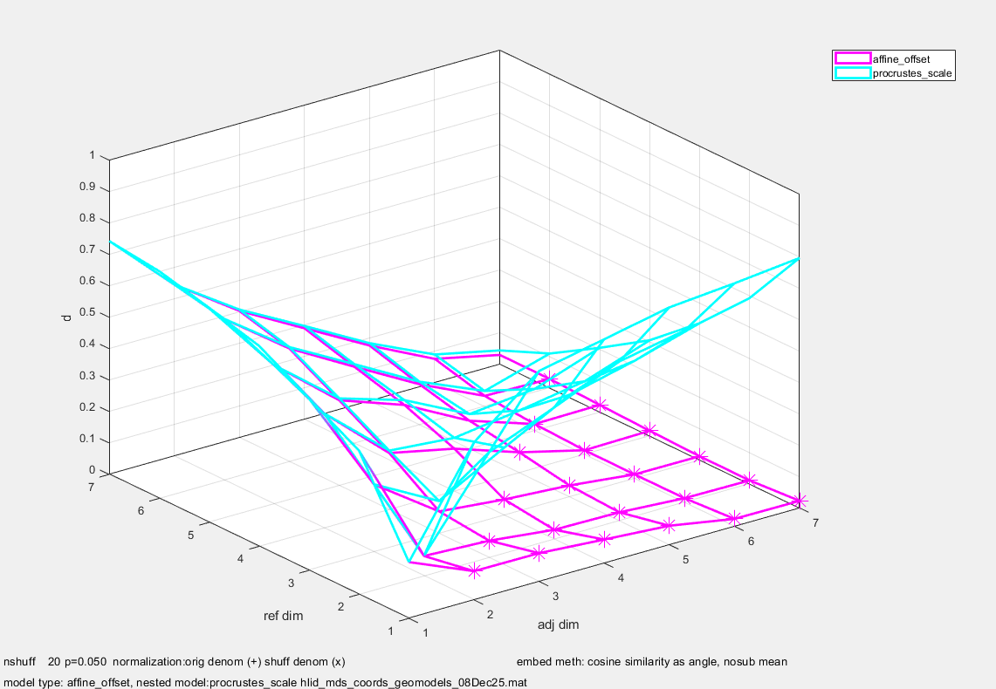

hlid_mds_coords_geo_10d_model-aff-offset-nested-proc-scale_cos_ang_nosub.fig

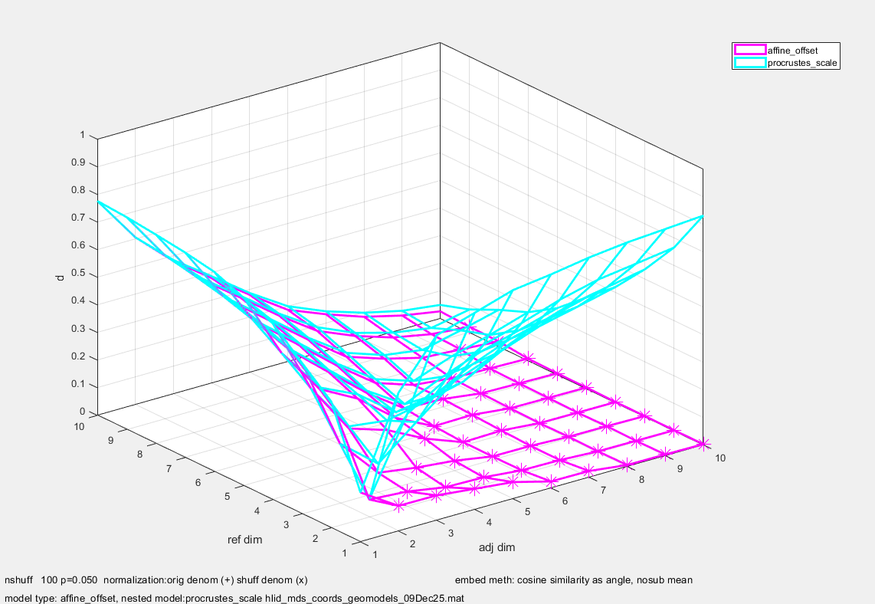

Projective is not an improvement over affine

hlid_mds_coords_geo_7d_model-proj-nested-aff-offset_cos_ang_nosub.fig

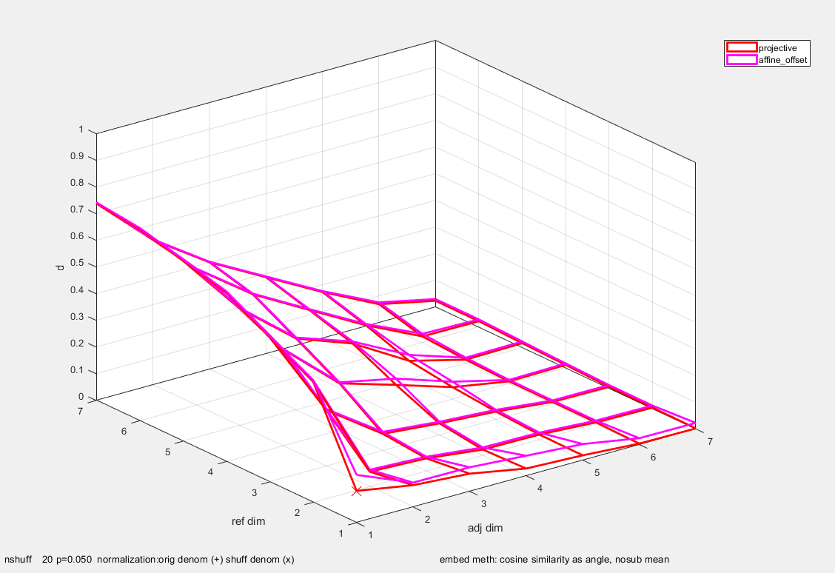

Piecewise affine is not an improvement over affine

hlid_mds_coords_geo_7d_model-pwaff-nested-aff-offset_cos_ang_nosub.fig

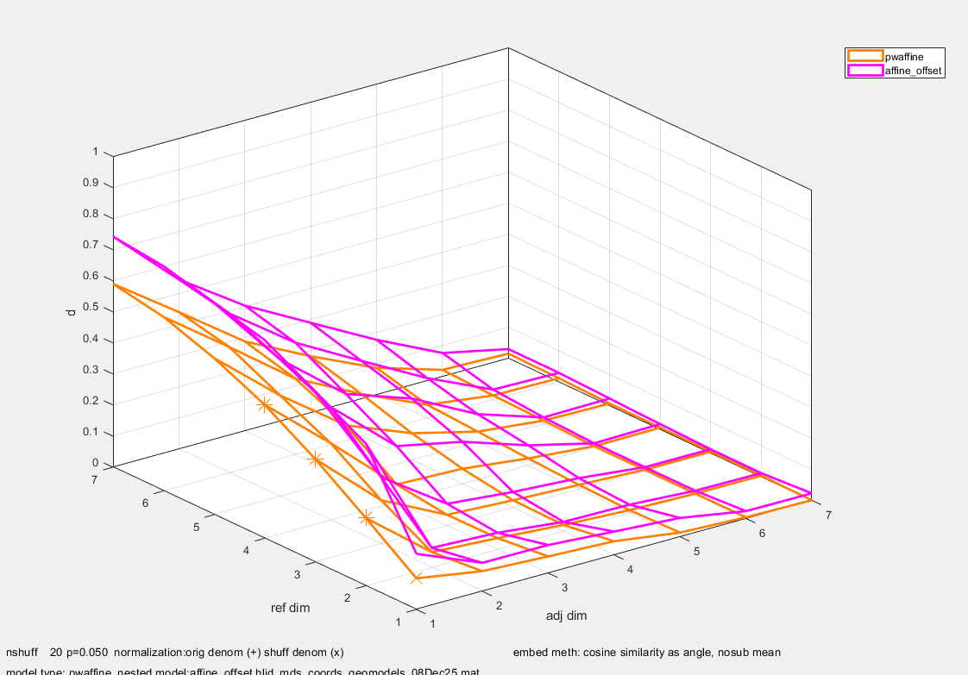

Affine model justified up to at least 5 dimensions

hlid_mds_coords_geo_7d_model-aff-offset-nested-by-dim_cos_ang_nosub.fig

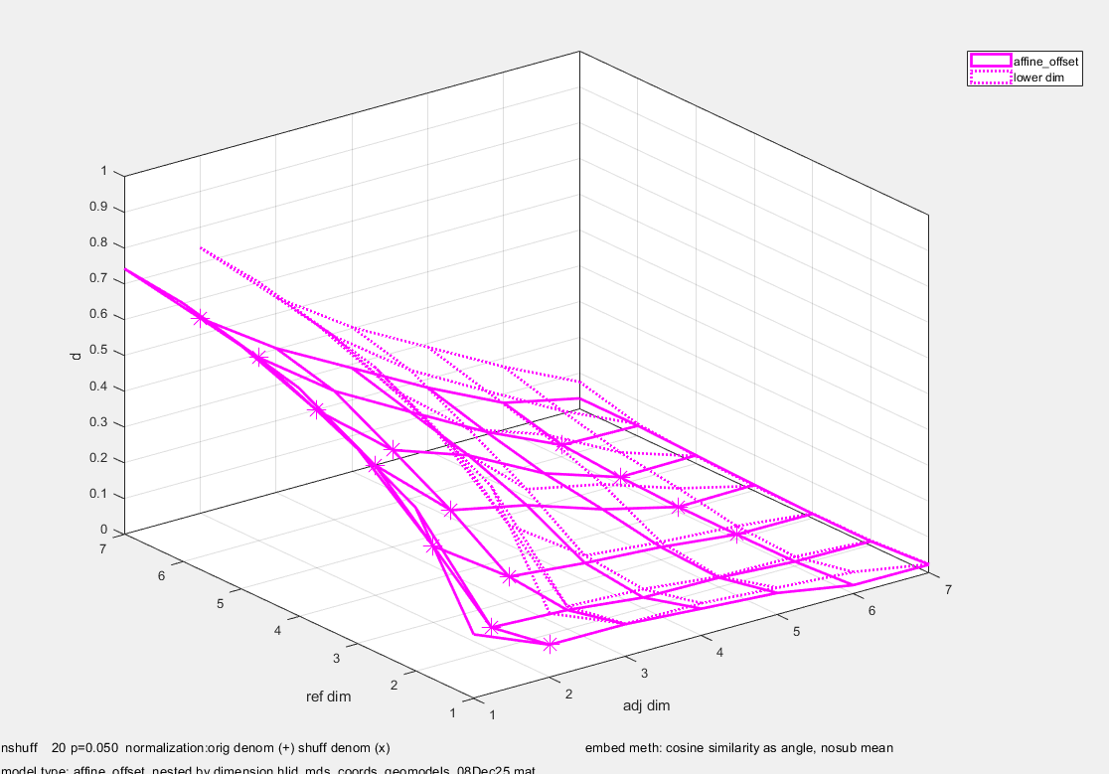

hlid_mds_coords_geo_10d_model-aff-offset-nested-by-dim_cos_ang_nosub.fig

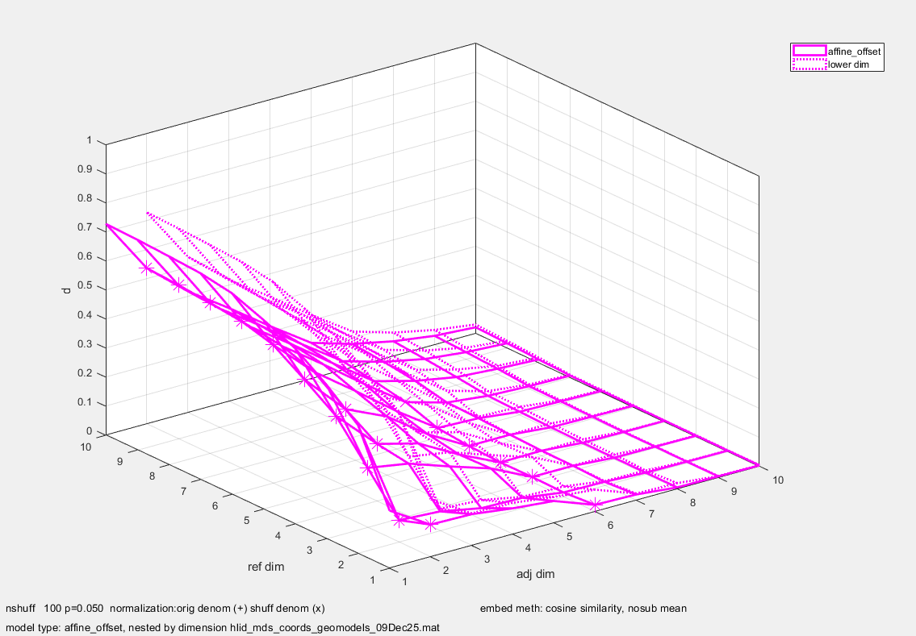

### Variance explained in the maps based on the alternative embeddings

As a function of dimension (column), – no consistent winner for 3d or 4d fits: with mean not subtracted (black), euc is slightly worse in 3d than Pearson but better than cosine, slightly better in 4d and 5d. With mean subtracted (red), it is worse than Pearson and cosine in 3d and 4d but comparable in 5d.

mean not subtracted

Euc dist SVD 0.1508 0.3708 **0.0675 0.0635 0.0678** 0.0272

Euc dist MDS 0.6152 0.2090 0.0664 0.0670 0.0348 0.0560

cos sim 0.1397 0.0765 0.1936 0.1174 0.0892 0.0412

cos ang 0.1169 0.0639 **0.0913 0.1144 0.0885** 0.0409

cos chord 0.1059 0.0623 0.0814 0.1169 0.0877 0.0408

Pearson sim 0.1424 0.2105 0.0727 0.1075 0.0805 0.0414

Pearson ang 0.0828 0.0543 **0.0602 0.1029 0.0833** 0.0416

Pearson chord 0.0866 0.0868 0.0584 0.1035 0.0556 0.0413

mean subtracted

Euc dist SVD 0.6152 0.2090 **0.0664 0.0670 0.0348** 0.0560

Euc dist MDS 0.6152 0.2090 0.0664 0.0670 0.0348 0.0560

cos sim 0.0379 0.0404 0.0417 0.0384 0.0300 0.0542

cos ang 0.0407 0.0403 **0.0391 0.0379 0.0313** 0.0576

cos chord 0.0407 0.0388 0.0352 0.0486 0.0324 0.0496

Pearson sim 0.1185 0.0337 0.0382 0.0375 0.0297 0.0548

Pearson ang 0.3141 0.0338 **0.0352 0.0373 0.0302** 0.0580

Pearson chord 0.3249 0.0335 0.0309 0.0418 0.0302 0.0641

Analysis via via hlid_mds_transform_comparefits.[m,txt], which reads plots\hlid_mds_transform_stats_01Jan26.mat. This file also has magnification data and projection of odors onto axes, and is used below.

### Statistics on principal axes

#### Statistics across preps (bootstrap and shuffle)

As a test for consistency across preps, we did a bootstrapping, in which we randomly drew, with replacement, from the 8 tnt preps to make a surrogate tnt dataset, and similarly, from the 11 3c preps to make a surrogate 3c dataset. This was only done for the Euclidean embedding.

Looked at distribution of the inferred magnification factors, and the cosine of the angle between the bootstrapped estimates of principal directions with those of the real data.

Analysis with hlid_geom_transform_stats_08Apr25.txt invoking hlid_geom_transform_stats.m, results saved as hlid_geom_transform_stats_08Apr25, plotting with hlid_geom_transform_stats_summ, making figs in plots\hlid_geom_transform_stats_08Apr25_figs.zip (minor bug fix, rerun with hlid_geom_transform_stats_[01|04]Jan26.txt)

Ran with embedding single trial sand forming a consensus (“single_trial”), emedding trial-averages and forming a consensus (“trial_ave”) or embedding single trials, averaging across trials, and then forming a consensus.’

Ran without (left) and with (right) subtracting the mean, and without (top) and with (bottom) normalizing z-scores to RMS of 1.Blots show distribution of bootstraps, and error bars show 95% range of bootstraps.

Cosmag files (hlid_geom_transform_stats_08Apr25_[singletrial|trial_ave|singletrialthenave]_entq50_cosmag.fig) Distribution of angle cosines of principal axes in adj and ref space, and of magnification factors, boot vs data (singletrialthenave files: also as _b50)

Black, blue, cyan, red, yelow, green: principal axes 1 to 6. Bottom to top: models of increasing dimension.

**Reasonable separation of the magnification factors in model dimension 3 (third row from bottom). Good consistency of axes – cosines close to 1.**

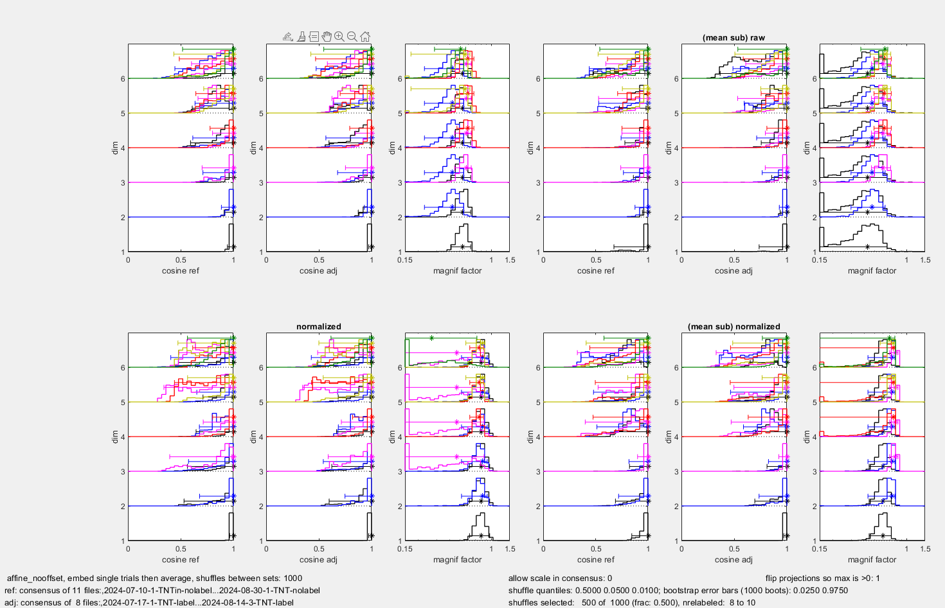

wtadj and wtref files: hlid_geom_transform_stats_08Apr25_[singletrial|trial_ave|singletrialthenave]_entq50_wt[adj|ref].fig): projections of the odorants onto the principal axes. Same layout as cosmag.

**Consistency of weights in model dimensions 3,4**

Adj: (label space)

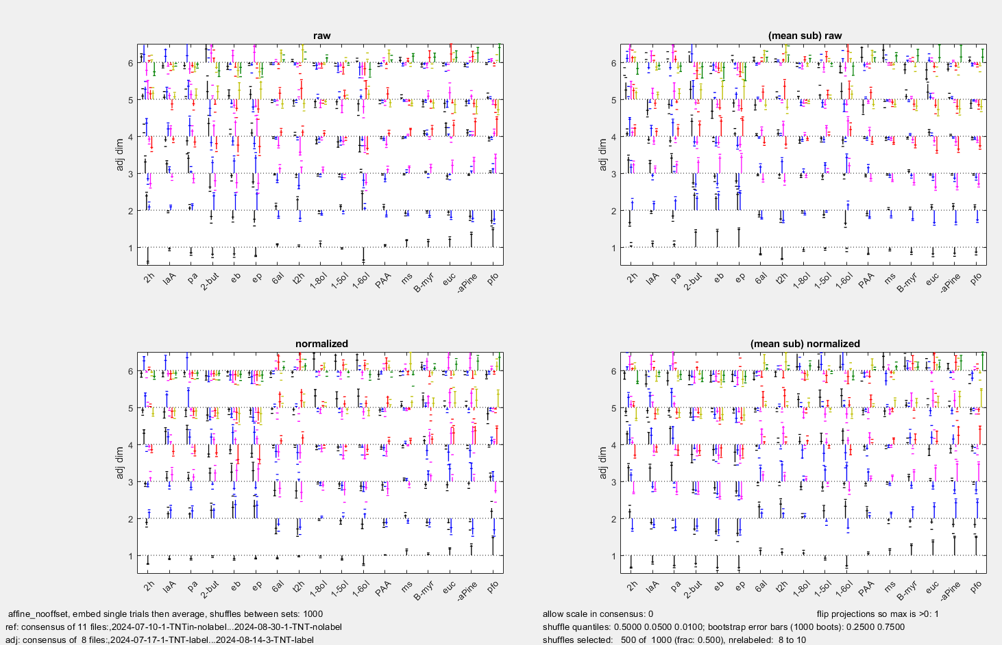

Ref: (3c space)

#### Consistency across stimuli

These analyses looked at whether the gain changes were driven by single stimuli – probably this is more crucial, as what is limiting is how well the stimulus space is sampled Here, the entire analysis pipeline, with the 8embedding methods, was repeated with one odorant held out. Distances are normalized within each embedding, for RMS of 1. For computing cosines with the full dataset, that odor’s projection was deleted, and the dot products were computed among the 17-1=16 odors.  **Main conclusion, no single odorant drives the phenomenon.**

Workflow for analysis of ratio of gain changes, consistency of principal axes: hlid_mds_transform_jackstats_03Jan26.txt running hlid_mds_transform_jackstats.m, creating hlid_mds_transform_jackstats_03Jan26.mat.

Survey of magnification factors: hlid_mds_transform_jackstats_summ_03Jan26.txt, invoking hlid_mds_transform_jackstats_summ.m

hlid_mds_transform_jackstats_summ_[r12|r1n|r1g]_by[meth|dim][_exp].fig show ratios of axes (r12: highest to next-highest, r1n: highest to lowest, r1g: highest to geomean) for the 8 embeddings, each stimulus left out (color), or mean (solid black), or median (dashed black). No single odorant seems to drive things – there are occasional large dependences, but no single odor drives the phenomena, and the outliers are mure prominent for dimensions 5 and 6 than for dimensions 3 and 4.. Plots are by embedding method (“bymeth”), or by dimension (“bydim”), also on an expanded scale (_exp).

This is highest to next-highest, showing each embedding method in a panel (top: not subtracting mean, bottom, subtracting mean) hlid_mds_transform_jackstats_summ_r12_bymeth_exp.fig.

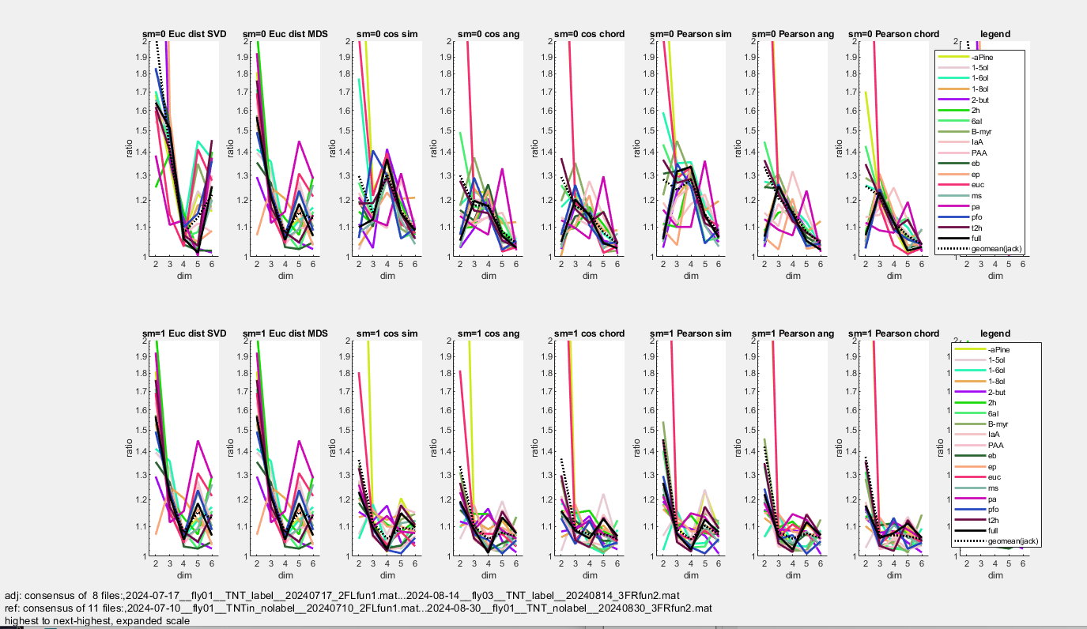

This is highest-to-next-highest, showing each dimension in a panel. hlid_mds_transform_jackstats_summ_r12_bydim_exp.fig

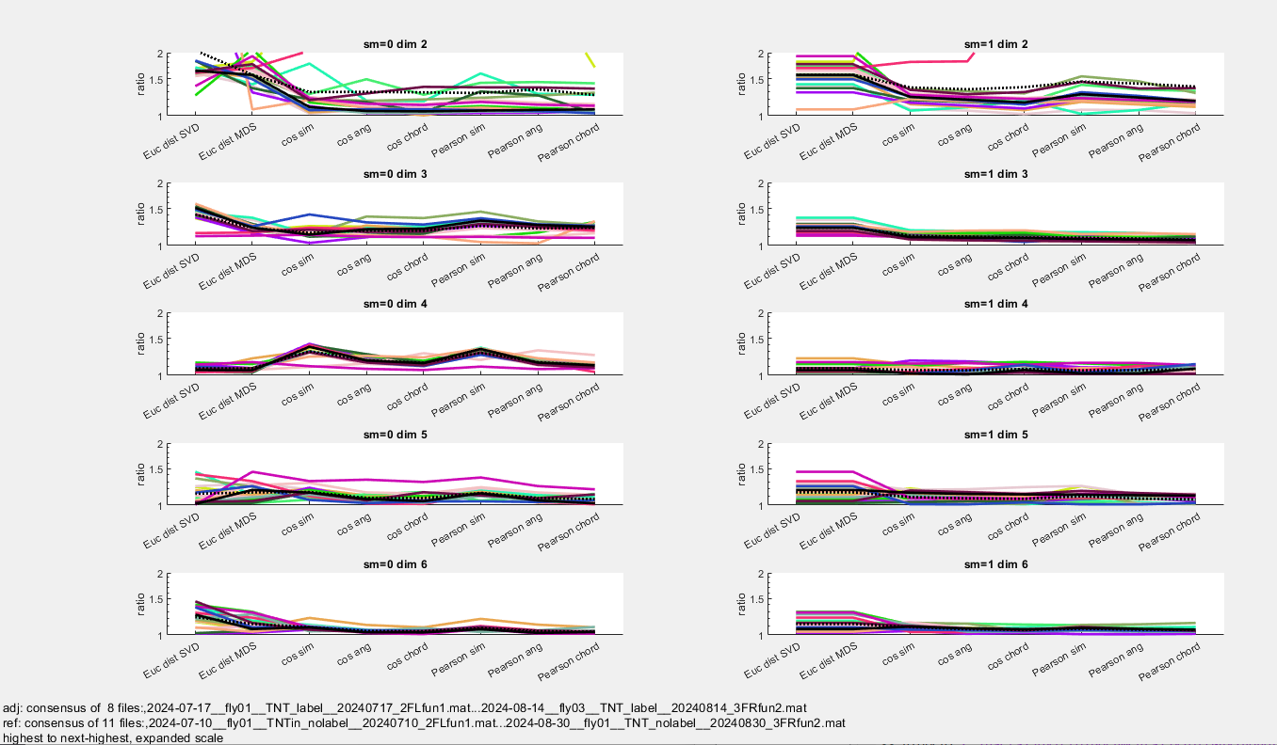

Consistency of magnification factors and directions: hlid_mds_transform_jackstats_summ2.txt, invoking hlid_mds_transform_jackstats_summ2.m

Log of …summ2.txt shows max Euclidean dimension

group 1: max Euclidean dimension (minimum across files)

data min(jackknife by stim)

sm=0 sm=1 sm=0 sm=1

Euc dist SVD 17 17 16 16

Euc dist MDS 17 17 16 16

cos sim 10 10 7 4

cos ang 17 17 16 11

cos chord 17 17 16 16

Pearson sim 10 10 7 6

Pearson ang 17 17 16 14

Pearson chord 17 17 16 16

group 2: max Euclidean dimension (minimum across files)

data min(jackknife by stim)

sm=0 sm=1 sm=0 sm=1

Euc dist SVD 17 17 16 16

Euc dist MDS 17 17 16 16

cos sim 8 5 7 4

cos ang 17 12 16 11

cos chord 17 17 16 16

Pearson sim 8 7 7 6

Pearson ang 17 15 16 14

Pearson chord 17 17 16 16

hlid_mds_transform_jackstats_summ2_mag_allembed.fig: Jackknife error bars are middle 0.5 quantile. Note that, since distances are normalized within each embedding, magnification factors scatter around 1. Leave-one-out analysis shows consistency.

This is hlid_mds_transform_jackstats_summ2_mag_allembed.fig, 8 embeddings, no sub mean at top, sub mean at bottom.

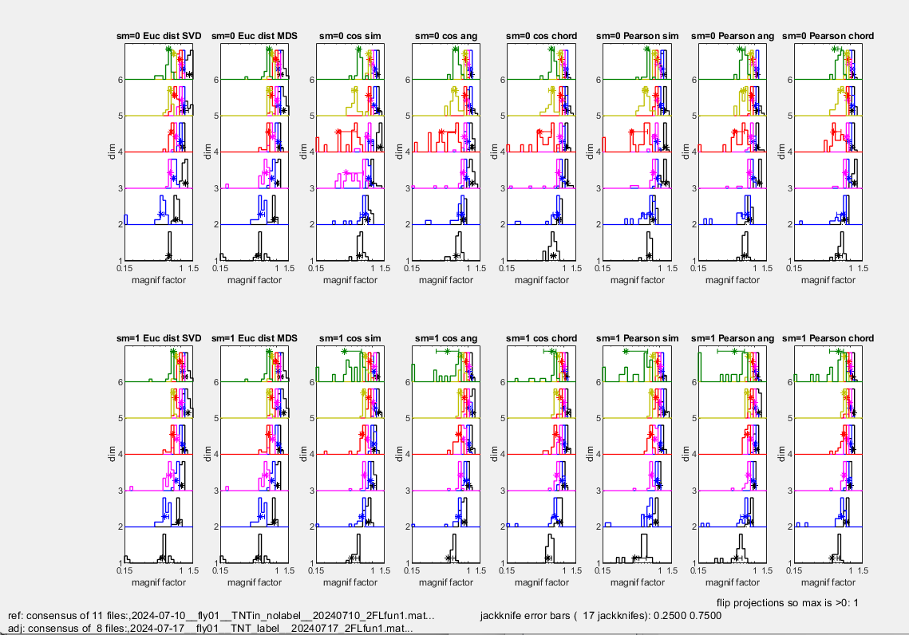

For consistency of directions: **greatest in 3- and 4-d models. Best for Euclidean models (first two colunns). Likely this is because the magnification factors are all closer to 1 in the nonstandard embedings (which are on a sphere), so it is not so easy to distinguish between the direction with the most, and the next-most stretch.**

cosines in tntlabel space: hlid_mds_transform_jackstats_summ2_cos_adj_allembed.fig

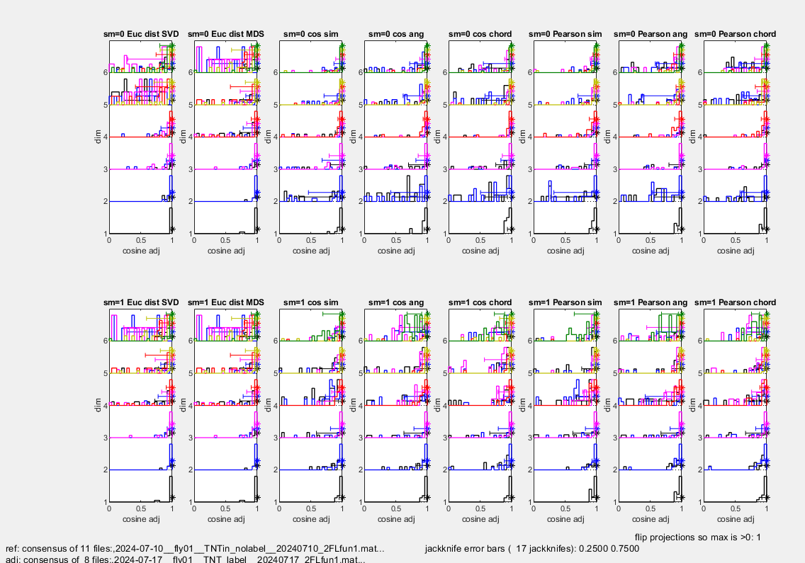

Cosines in tnt3c space: hlid_mds_transform_jackstats_summ2_cos_ref_allembed.fig

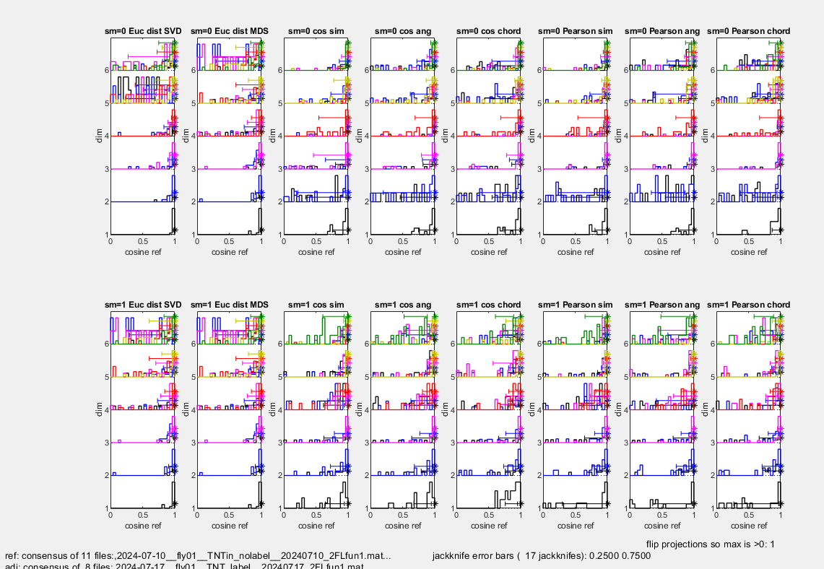

Projections of the odorants onto the axes – only 3 emgbeddings shown here, but also have “allembeds” figs with all 8. Consistency across embeddings, and larger-weights are consistent across leave-one-out. Error bars are middle 0.5 quantile.

In tntlabel space, SVD (Euclidean), cosine angle, and pearson angle: hlid_mds_transform_jackstats_summ2_proj_adj_3embeds.fig

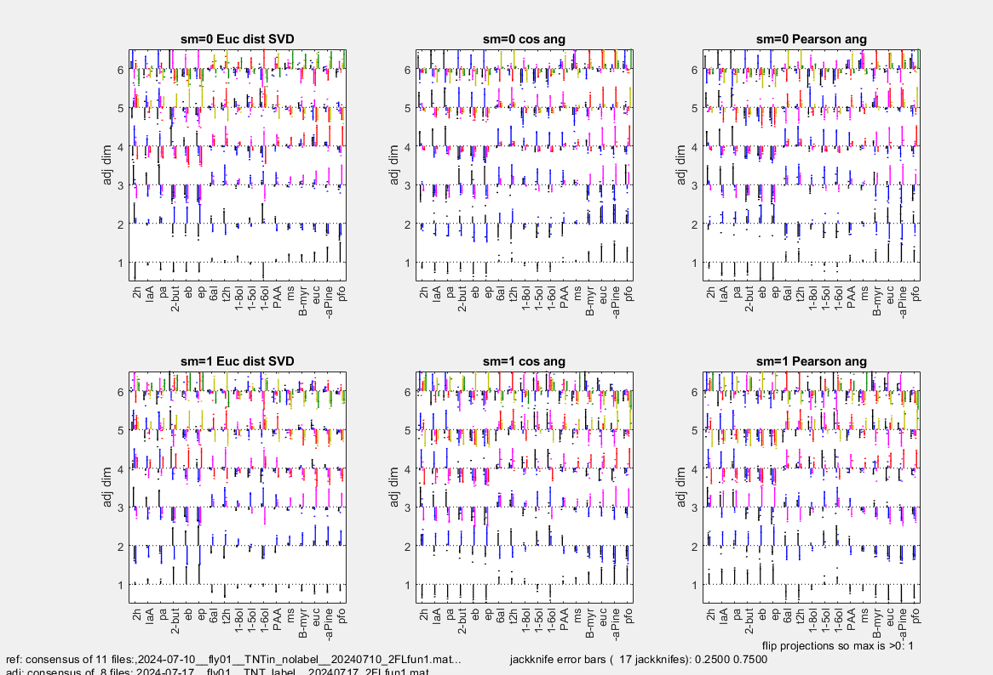

In tnt3cspace, SVD (Euclidean), cosine angle, and pearson angle: hlid_mds_transform_jackstats_summ2_proj_ref_3embeds.fig

